Transfer Runs/Transfer Stops
Frequently students need to be delivered to a school but there are no vehicles/runs in the student’s vicinity for that particular school. However, when there are other vehicles in the area and district policy allows students from multiple schools to ride the same vehicle, students may be picked up with other students, and through transfers, reach their final destination. There are two ways to treat transfers.
- The first option is to pick up multiple schools on one bus and drop at each school in the time windows allowed by the stops for the drop off schools. Stops for all involved schools are moved to the workspace and a single vehicle is used to solve the run.

- For the second option the student has two transportation assignments: one that contains pickup to transfer point and then transfer point to final drop off. The transfer point stop may be used for as many students as will be picked up at the transfer point.

Multiple School Runs

- In the Runs tab, select the run to which the transfer stop/student will be added. Move the run to the workspace.
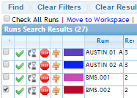

- In the stops, select the student’s stop. Move the stop to the workspace.
NOTE: The additional school will be added automatically.

- In the workspace, if VRP settings have not been set, verify the settings are appropriate for the run to be solved.

- Click to solve the run.

- When the run has solved, verify the new stop is in the correct location. If necessary, move the run back to the workspace and reorder the stops or make any change needed.

- The drop at the added school will be in the stop list in the appropriate position as determined by the times.

Transfer Runs
Transfer runs meet at a location such as a school to transfer students from one bus from another to continue to the student’s final destination. Each student will have two AM stops, also called a paired order. The first stop will be from the student’s neighborhood/home stop to the transfer location. The second will be from the transfer location to the student’s school of attendance. The second stop will be used for all students that are picked up at the transfer location to go to the school.
- Open the student’s record. Click on the Transportation tab. 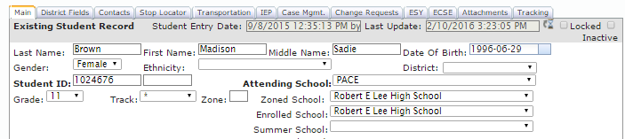

- If a new stop must be created from the home stop to the transfer stop, the user make use the stop creation form in the student’s transportation tab.*
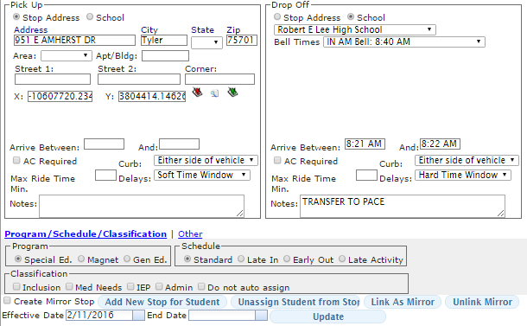
In this example, the student is being transported to the zoned school for the student. A note is made on the Drop Off side of the stop regarding the student transferring to PACE. The note is an optional step.
*Point and click stop creation, stop creation in the stop screen, or creating the stop in the student record are all options for creating the stop.

- Click . Compass will create the stop and add the information to the Stop Assignments for Student.

- To create the transfer stop, in the pickup side of the stop form select the school where the student was dropped for transfer.* In the drop off side of the stop form, select the school which is the student’s final destination. 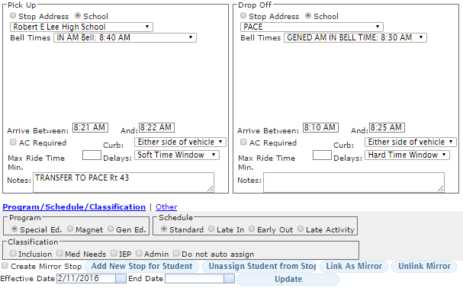
*NOTE: The transfer location could be a parking lot, library, school, or any location where buses can meet. If it isn’t a school, as in the example, use the stop address option to geocode the transfer location and add helpful information in the Notes field for clarification.
- Click to add the stop to the student’s record. The transfer stop will be added to the student’s stop assignments. 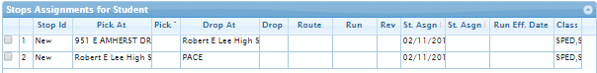

- Click to save the student information. Compass at that point will give the new stops stop IDs. 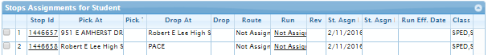

- Add the Transfer Stop to a new run or existing run. 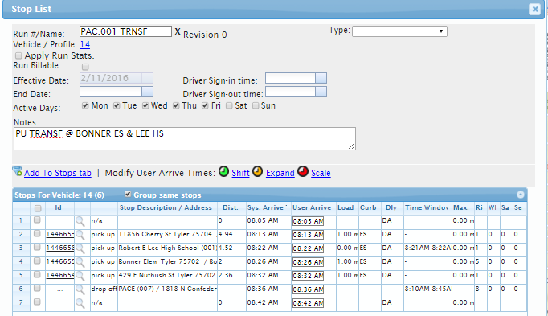
Pickup transfer students at Lee HS. Pickup walking transfer students at Bonner Elem.

NOTE: If the student walks to a transfer stop, simply add the transfer stop to a new or existing run.

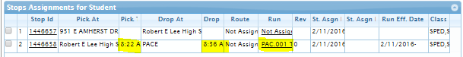

DRIVER DIRECTIONS: The driver directions will show the following notes:
