Re-Image Edge HiDef via Symantec Ghost

v. 1.0

COBAN® Technologies Inc.
11375 West Sam Houston Parkway South, Suite 800
Houston, Texas 77031
Tel: 1-281-925-0488
Fax: 1-281-925-0535

http://www.cobantech.com

Table of Contents
1 Before you begin 3
2 Using Symantec Ghost 5

Table of Figures
Figure 1: Before you begin 3
Figure 2: BIOS Advanced menu 3
Figure 3: Disable SATA port 1 4
Figure 4: Identify name and size of internal drive 4
Figure 5: Plug in the storage device into the USB 1 slot 5
Figure 6: About dialog box 5
Figure 7: Symantec menu 6
Figure 8: Image file name to restore from dialog box 6
Figure 9: Select the image 7
Figure 10: Select local destination 7
Figure 11: Destination Drive Details dialog box 8
Figure 12: Confirmation message 8
Figure 13: Reimage progression 9
Figure 14: Reset the computer 9

Before you begin
Before you can begin the reimage, follow these steps:
- Ensure you have retrieved the correct ghost image from our customer website or from a previous captured image.
- Place the ghost image onto a bootable storage device (USB Flash Drive) with Symantec Ghost.
NOTE: A ghost image and the ghost software are provided on a USB flash drive with the tech support kit typically purchased during initial deployment. If misplaced or outdated, contact technical support for assistance or an updated image. It is recommended you check with support for updated images at least once a year.

- Remove the MHDD (Mobile Hard Drive).
WARNING! Failure to remove the MHDD can result in an image of the wrong destination drive.
- Connect a keyboard to the CPU. You can also connect it to the side of the monitor.
- Restart the CPU, then press the <DEL> or <F2> key when prompted to enter system BIOS.
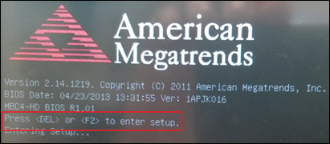
Figure 1: Before you begin
- Using your keyboard arrows, select IDE Configuration from the Advanced menu, then press Enter.
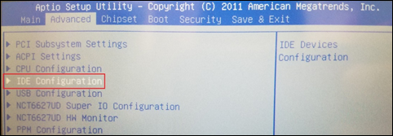
Figure 2: BIOS Advanced menu
The IDE Configuration screen is displayed.
- Identify both name and size of both internal drives.
NOTE: The SATA Port1 should be the larger of the two ports.

- Press the down arrow on your keyboard to select SATA Port 1, then press Enter. A pop-up menu is displayed.
- Press the down arrow on your keyboard to select Disabled, then press Enter.
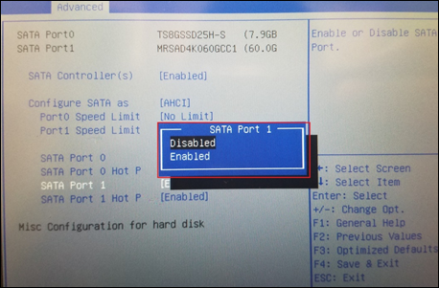
Figure 3: Disable SATA port 1
The status for SATA Port 1 is now displayed as [Disabled].
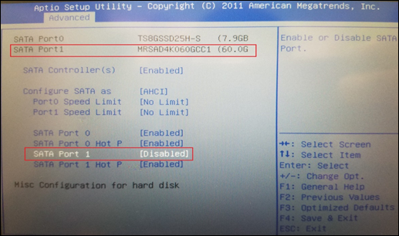
Figure 4: Identify name and size of internal drive
- Click F4 on your keyboard to save the settings and exit BIOS.
- Shut down the CPU.
- Plug in the storage device into the USB 1 slot on the front of your CPU.
WARNING! Do not use the USB on the monitor for the Ghost drive and/or where the Image is contained, as this USB port is 1.1 and will result in extremely slow imaging process.

NOTES: It may take several minutes for Symantec Ghost to start up.
- Power the CPU on.
NOTE: Verify the MHDD has been removed from the CPU prior to powering the CPU on.
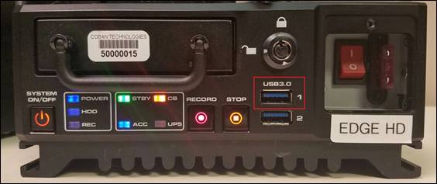
Figure 5: Plug in the storage device into the USB 1 slot

Using Symantec Ghost
To use Symantec Ghost, follow these steps:
- After you power on the CPU with the USB storage device connected, click OK on the About dialog box.
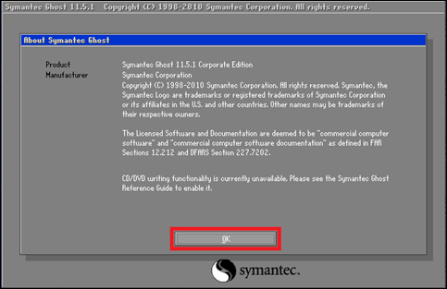
Figure 6: About dialog box

- On the Symantec home screen, choose Local > Disk > From Image from the Symantec menu.
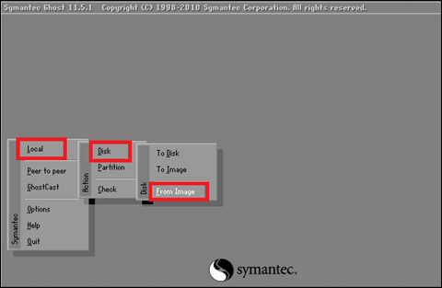
Figure 7: Symantec menu
The Image file name to restore from dialog box is displayed.
- Select the drive where the ghost image (.GHO) is stored from the Look in drop-down list.
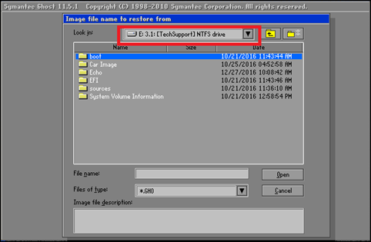
Figure 8: Image file name to restore from dialog box

- Select the desired image, then click Open.
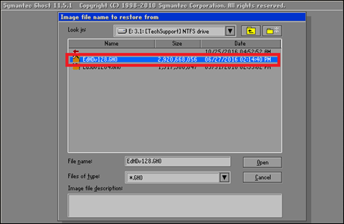
Figure 9: Select the image
The Select local destination drive dialog box is displayed.
- Navigate to your local destination drive.
- Ensure you select the drive with the smaller size (MB), which is usually “Drive 1”, then click OK. For example, a local drive 1 is 7627 MB, whereas drive 2 is 57241.
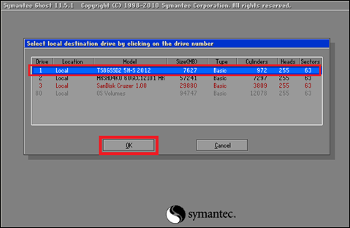
Figure 10: Select local destination
The Destination Drive Details dialog box is displayed.

- Click OK to select the default drive.
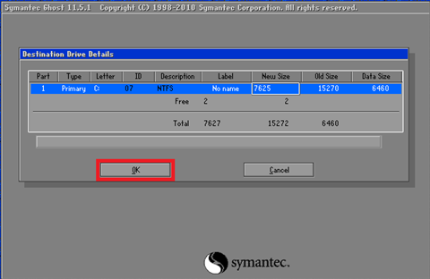
Figure 11: Destination Drive Details dialog box
A confirmation dialog box is displayed.
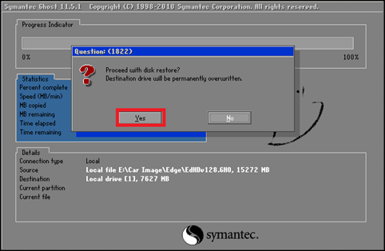
Figure 12: Confirmation message
- Click Yes to proceed with the disk restore.

Symantec Ghost proceeds through the reimaging of the internal drive. The Progress Indicator tab display the progress.
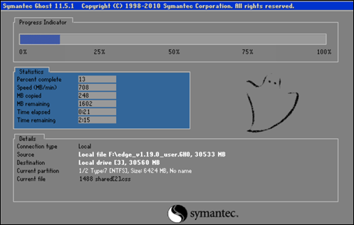
Figure 13: Reimage progression
NOTE: If a decompression error is displayed, repeat steps 1 -7. If the error persists, you may have either a bad/corrupted ghost image (.gho file) or a failing internal hard drive. Contact COBAN Technical Support.
- Once complete, a confirmation message is displayed stating the clone was completed successfully.
- Click Reset Computer.
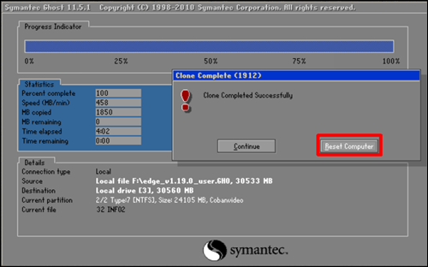
Figure 14: Reset the computer

