

*Mobile Recorder User Guide*

*v. 4.10*

COBAN® Technologies Inc.

11375 West Sam Houston Parkway South, Suite 800

Houston, Texas 77031

Tel: 1–281–925–0488

Fax: 1–281–925–0535

<http://www.cobantech.com>

**Copyright**

THE SPECIFICATIONS AND INFORMATION REGARDING THE PRODUCTS IN THIS MANUAL ARE SUBJECT TO CHANGE WITHOUT NOTICE. ALL STATEMENTS, INFORMATION, AND RECOMMENDATIONS IN THIS MANUAL ARE BELIEVED TO BE ACCURATE BUT ARE PRESENTED WITHOUT WARRANTY OF ANY KIND, EXPRESS OR IMPLIED. USERS MUST TAKE FULL RESPONSIBILITY FOR THEIR APPLICATION OF ANY PRODUCTS.

THE SOFTWARE LICENSE AND LIMITED WARRANTY FOR THE ACCOMPANYING PRODUCT ARE SET FORTH IN THE INFORMATION PACKET THAT SHIPPED WITH THE PRODUCT AND ARE INCORPORATED HEREIN BY THIS REFERENCE. IF YOU ARE UNABLE TO LOCATE THE SOFTWARE LICENSE OR LIMITED WARRANTY, CONTACT YOUR COBAN TECHNOLOGIES REPRESENTATIVE FOR A COPY.

NOTWITHSTANDING ANY OTHER WARRANTY HEREIN, ALL DOCUMENT FILES AND SOFTWARE OF THESE SUPPLIERS ARE PROVIDED “AS IS” WITH ALL FAULTS. COBAN TECHNOLOGIES AND NAMED SUPPLIERS DISCLAIM ALL WARRANTIES, EXPRESSED OR IMPLIED, INCLUDING, WITHOUT LIMITATION, THOSE OF MERCHANTABILITY, FITNESS FOR A PURPOSE AND NON-INFRINGEMENT OR ARISING FROM A COURSE OF DEALING, USAGE, OR TRADE PRACTICE.

IN NO EVENT SHALL COBAN TECHNOLOGIES OR ITS SUPPLIERS BE LIABLE FOR ANY INDIRECT, SPECIAL, CONSEQUENTIAL, OR INCIDENTAL DAMAGES, INCLUDING, WITHOUT LIMITATION, LOST PROFITS OR LOSS OR DAMAGE TO DATA ARISING OUT OF THE USE OR INABILITY TO USE THIS MANUAL, EVEN IF COBAN TECHNOLOGIES OR ITS SUPPLIERS HAVE BEEN ADVISED OF THE POSSIBILITY OF SUCH DAMAGES.

COBAN AND THE COBAN LOGO ARE TRADEMARKS OF COBAN TECHNOLOGIES. THIRD-PARTY TRADEMARKS MENTIONED ARE THE PROPERTY OF THEIR RESPECTIVE OWNERS. THE USE OF THE WORD “PARTNER” DOES NOT IMPLY A PARTNERSHIP RELATIONSHIP BETWEEN COBAN TECHNOLOGIES AND ANY OTHER COMPANY.

ANY INTERNET PROTOCOL (IP) ADDRESSES AND PHONE NUMBERS USED IN THIS DOCUMENT ARE NOT INTENDED TO BE ACTUAL ADDRESSES AND PHONE NUMBERS. ANY EXAMPLES AND FIGURES INCLUDED IN THE DOCUMENT ARE SHOWN FOR ILLUSTRATIVE PURPOSES ONLY. ANY USE OF ACTUAL IP ADDRESSES OR PHONE NUMBERS IN ILLUSTRATIVE CONTENT IS UNINTENTIONAL AND COINCIDENTAL.

*Mobile Recorder User Guide v4.10*

2018 COBAN™ TECHNOLOGIES. ALL RIGHTS RESERVED.

**Revisions**

|  |  |  |
| --- | --- | --- |
| 4/18/2018 | Initial draft | *v4.10* |

Table of Contents

1 Introduction 5

2 Log into the Mobile Recorder 5

2.1 Manually Start the Application 7

2.2 Other Login Options 7

3 Sync the Wireless Microphone 8

4 Camera View Screen 9

5 Recording a Video 11

5.1 Manually Record a Video 11

5.2 Use Wireless Microphone to Start Recording 12

5.2.1 Wireless Microphone Alerts 12

5.3 Other Recording Options 12

5.4 Stop a Recording 13

6 Classify Recordings with Event Types 14

6.1 Select an Event Type 14

7 Taking a Snapshot 16

8 Bookmark a Video 18

9 Additional Functions 19

9.1 System Summary 19

9.2 Close Shot 20

9.3 View Snapshots 20

9.4 PreEvent Playback 21

9.5 Equipment Test 21

9.6 Sync GPS Time 22

9.7 Edit Event Data 22

9.8 Enable Live Audio 22

9.9 IP Address 22

9.10 Record Indicator 22

9.11 Traffic Watch 22

9.12 Night Mode 22

9.13 Color Mode 22

10 Obtain COBAN Support 23

Table of Figures

Figure 1: TopCam -G2 Figure 2: EDGE 5

Figure 3: Log in screen 5

Figure 4: System Time and Date 6

Figure 5: Camera View Screen 6

Figure 6: Manually Start the Application 7

Figure 6: Sync the Wireless Microphone 8

Figure 8: Camera View Screen 9

# Introduction

The COBAN mobile recorder is the front line of the Digital Video Management System (DVMS®), developed by COBAN Technologies Inc®. The mobile recorder allows users to record two channels of audio and two channels of video streams simultaneously to the in-car CPU. This information is stored in the Mobile Hard Disk Drive until it can be transferred to the BOClient®.

# Log into the Mobile Recorder

Based on the system settings configured by the department users may need to login to the mobile recorder system using a valid user ID and password at the beginning of each shift. This information allows the mobile recorder system to transfer videos taken during the shift to BOClient to be properly stored and classified in DVMS. Complete the steps described in this section to login to the mobile recorder system.

*To log into the mobile recorder, follow these steps:*

1. Start the vehicle.
2. Turn on the mobile recorder using the **On/Off** switch on the monitor.
3. Allow the system to boot up.

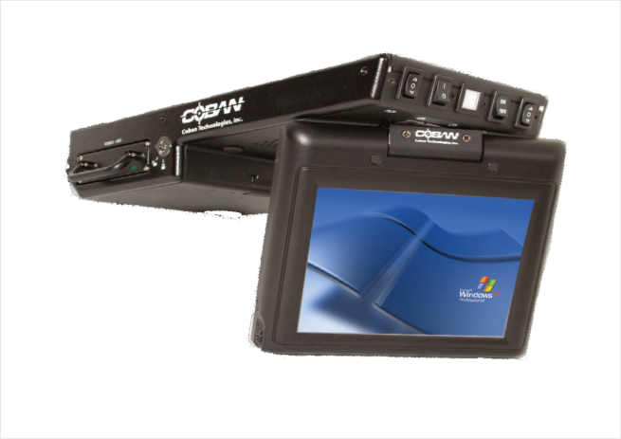 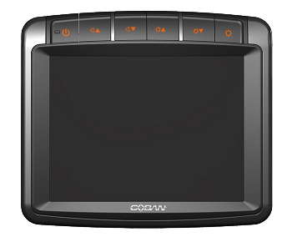

Figure 1: TopCam -G2 Figure 2: EDGE

The **COBAN Mobile Recorder Officer Login** screen is displayed.

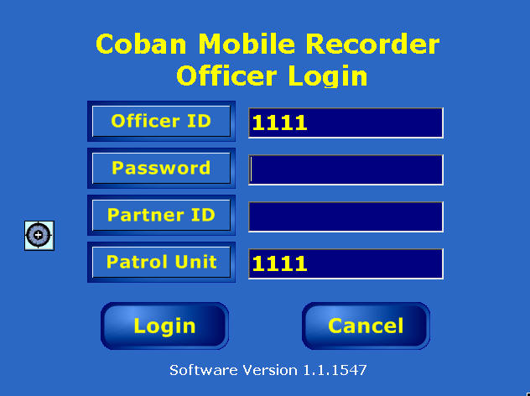

Figure 3: Log in screen

1. If necessary, enter the appropriate Officer ID in the field provided. This field may be pre-populated from MHDD checkout.

**NOTE**: Tap the individual fields to access the Virtual Keypad.

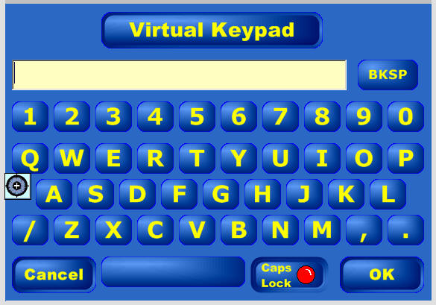

1. Enter your password, then click **OK**.
2. On the **Login** screen, click **Login**. The **System Time and Date** screen is displayed.

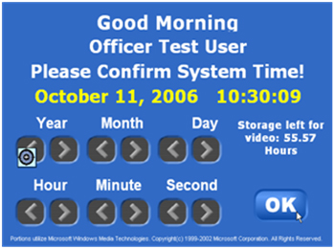

Figure 4: System Time and Date

1. Change the system time and date if it is incorrect using the appropriate arrow keys.
2. Make a note of the estimated remaining recording time. Storage remaining for video recording is displayed above the **OK** button.

**NOTE**: A warning prompt will be displayed if available recording time is less than 4 hours. The system will not allow the MHDD to be used if it has less than 10 minutes remaining.

1. Tap **OK**.

Upon successful login, the Officer ID number displays at the bottom right of the Camera View screen.

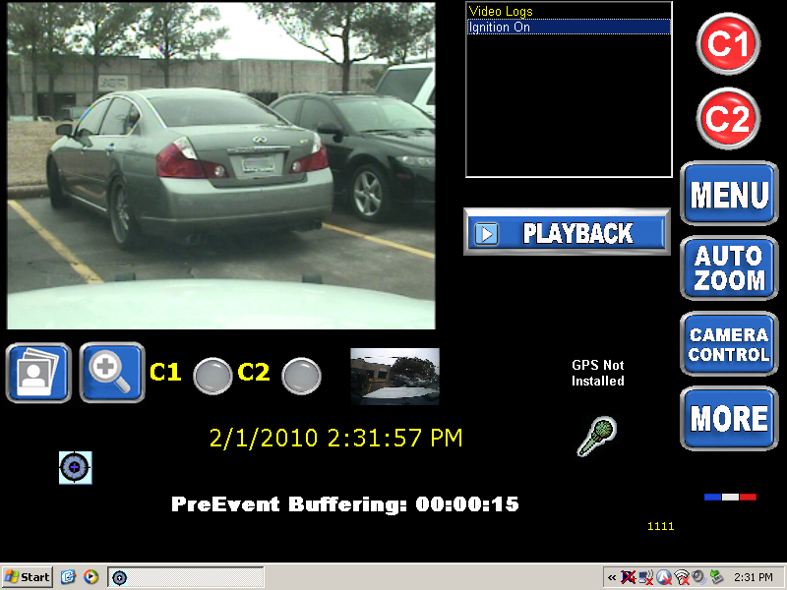

Figure 5: Camera View Screen

## Manually Start the Application

The system is designed to start automatically. If the system does not automatically start, contact the system administrator or manually start the application.

To manually start the mobile recorder application, double-click the **MobileStart** icon.

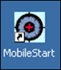

Figure 6: Manually Start the Application

## Other Login Options

The system administrator for DVMS can enable one of four different login capabilities. These four different options are described below:

* **Quick login** – Automatically logs in an officer after they login once, if the same hard drive is used in the same unit (typically used in take home vehicles).
* **Emergency login** – If this option is enabled, when the user starts the mobile recording system and the light bar is activated, the system will boot into record mode automatically. If the light bar is not activated, the system will remain at the login screen.
* **Delayed login** – If this option is enabled the officer can start up the mobile unit and will get a login prompt for 30 seconds. If the officer does not login within 30 seconds the mobile recorder program will start automatically with the ability to record a video. At the end of the recording period, once the stop button is pressed, the officer is prompted to login.
* **Windows login** – The administrator may set BOClient to use MS Windows login credentials and automatically login to BOClient. Note that users will need to logoff from the current Windows session so that others will not gain access to DVMS system with other users’ access rights. This feature requires MDT integration or a connection to the department network.

# Sync the Wireless Microphone

*To sync the wireless microphone, follow these steps:*

1. Locate the contacts at the bottom of the wireless mic.
2. Press the wireless microphone contacts directly on top of the receiver’s register contacts.

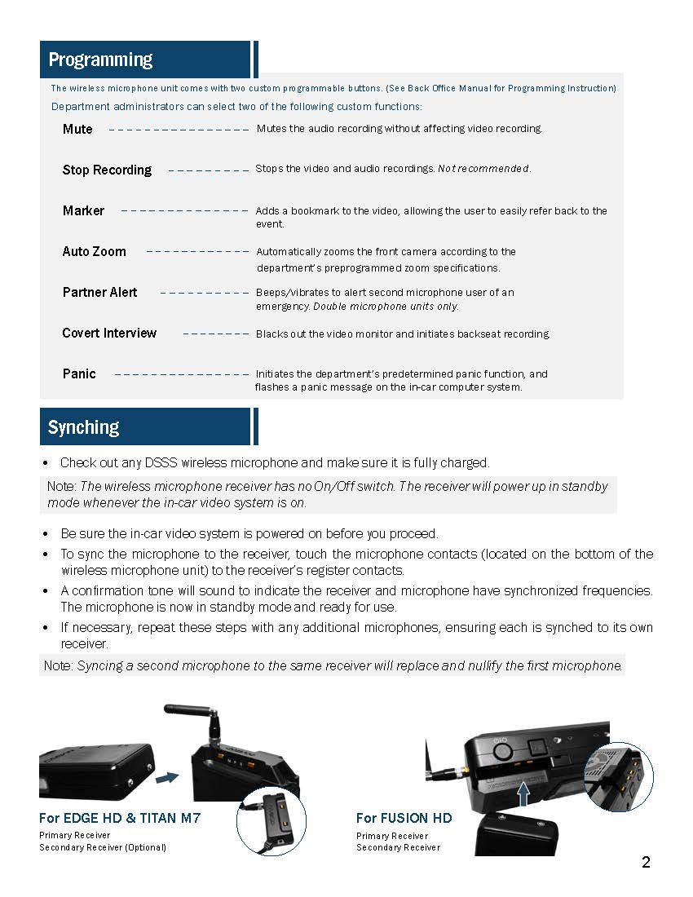 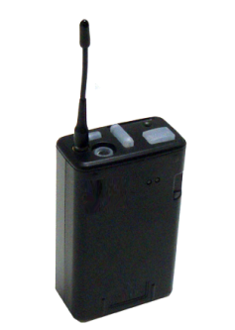

For H1

Figure 6: Sync the Wireless Microphone

A confirmation tone will sound to indicate the receiver and the microphone have synchronized their frequencies.

The wireless microphone is now on standby mode and ready for use.

**NOTE**: Syncing a second microphone to the same receiver will replace and nullify the first microphone.

# Camera View Screen

The Camera View screen displays the camera input and provides options for the user to start recording, create bookmarks, take snapshots of the video and other functions. It also provides icons that indicate the light bar status, radar gun reading, GPS indicator (if installed), and the in-car microphone **ON / OFF** status.

At the bottom of this screen, it shows the Pre-Event Buffering time, which indicates the length of video that is being pre-recorded prior to User tapping the **Record** button.

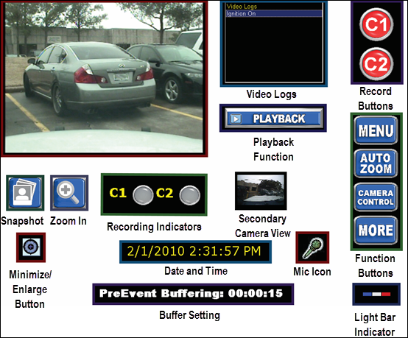

Figure 8: Camera View Screen

* **Camera** **Preview** – displays the image as seen through the camera lens. The default image is set as the front facing camera. The system supports a spot exposure feature. Tap the brightest portion of the camera preview screen to automatically dim the preview screen for five seconds. This feature is useful for when lights are making portions of the preview too bright to see.
* **Video** **Log** – documents readings and status from various devices connect to the mobile recording system such as, light bar status, microphone status, bookmark, etc.
* **Snapshot** **function** – saves a JPG freeze frame image of the video displayed on the camera preview screen. A preview of the snapshot will be displayed immediately beneath the snapshot icon for 15 seconds. Take a snapshot of the rear camera view by clicking on the C2 camera indicator to change the camera preview to secondary camera, then tap the snapshot icon.
* **Minimize/Enlarge** **button** – The minimize/enlarge button will minimize or enlarge the mobile recorder application and allow users the ability to access other programs on the computer.
* **Recording indicators** – The recording indicators blink red to signify which camera is recording. If no cameras are recording, the indicators will not blink. Users can tap on the recording indicators to make that cameras view active in the Camera Preview screen. When there is only one camera installed on the vehicle, the user will not see a C1 and C2 camera indicator. When three cameras are installed in the system, tapping the C2 camera indicator will toggle between camera’s two and three.
* **Date and Time** – The Date and Time display is set during the login sequence and continuously displays the current date and time.
* **Buffer setting** – The Pre-Event Buffer is set by the System Administrator through COBAN’s BOClient application. The Pre-Event Buffer display is a reminder to the user that all recordings are provided with a pre-event recording. This buffer can be adjusted through BOClient or in some cases through mobile recorder.
* **Mic** **icon** – The wireless microphone icon will blink when the covert microphone is recording audio.
* **Light Bar Indicator** – the light bar indicator will blink when the vehicles light bar is activated.
* **Function buttons** – provide users the access to greater functionality, including:
* **Menu button** – provides access to Camera View, Playback, Switch User, or Exit functions.
* **Bookmark** **icon** – Tap the bookmark icon to mark a spot in a video for later review or to pinpoint an action on the recording.
* **Auto** **Zoom** – If supported by the camera, when tapped, the system will automatically zoom the camera, pause for 3 seconds and zoom back to user’s original zoom setting. There is no need to manually disengage the button when this feature is used.
* **Camera Control** – Tap **Camera** **Control** to access manual camera zoom, brightness and focus capabilities when supported by camera.
* **More** – Allows users the ability to access additional system features and functions.
* **Secondary Camera View** – If installed, will be configured as C2 and the second camera’s view will appear below the primary camera image next to C2 indicator.
* **Playback Functions** – The playback feature allows user to play previously recorded video, enter/edit video event data, send selected video wirelessly (if wireless option is purchased) and manually retain video.
* **Record Buttons** – The user may initiate a recording by pressing the wireless microphone, turning on the light bar or siren (if equipped as a system trigger), or tapping the Record buttons on the screen.

# Recording a Video

The core feature of the mobile recording system is its ability to quickly and accurately capture videos when the user initiates a recording. The COBAN mobile recording system incorporates a multitude of options to start a recording, and to view videos as they are being recorded.

## Manually Record a Video

1. On the Camera View screen, tap the camera 1 icon to begin a recording using the primary camera.
2. On the Camera View screen, tap the camera 2 icon to begin a recording using the secondary camera.

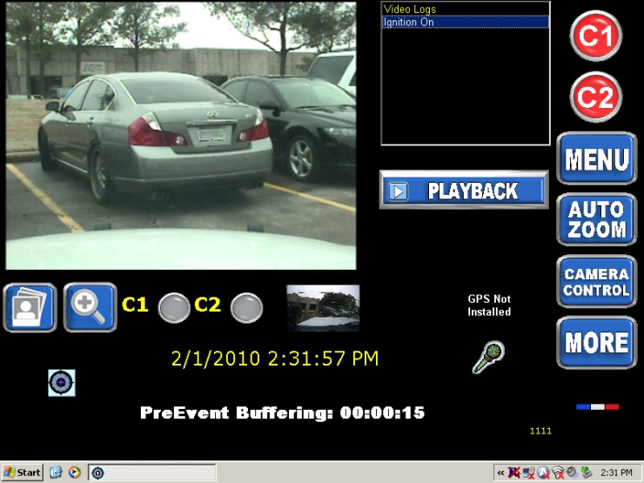

If the vehicle has three cameras, you can switch the display between camera 2 and camera 3 by double tapping the camera 2 indicator beneath the video image display.

Untitled-1.tif

The camera 1 icon is displayed as a white square when the mobile recorder is actively recording a video.

c1 and c2 B.tif

The recording indicators will blink red to signify which cameras are actively recording.

## Use Wireless Microphone to Start Recording

*To manually start a recording, follow these steps:*

Press the **Record** button (larger button) on the wireless mic once.

This action will initiate the mobile recorder to record both audio and video data via the mobile recorder.

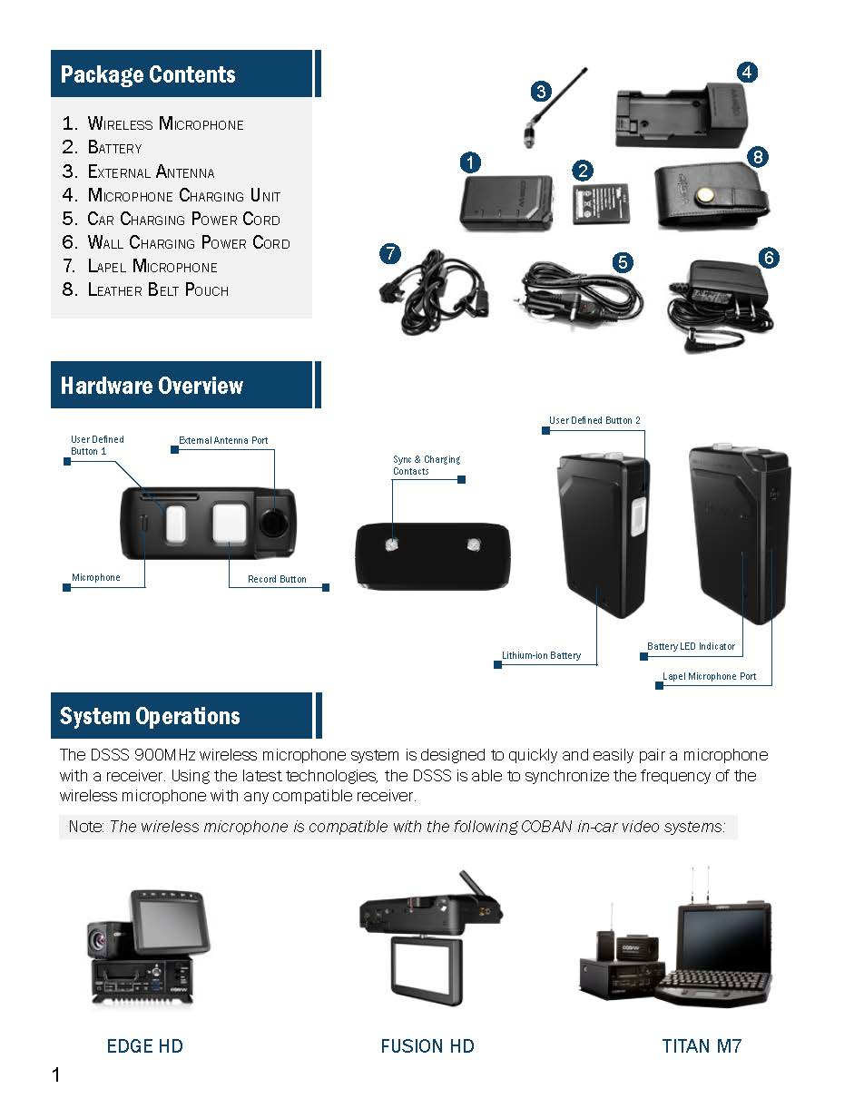

The wireless mic will vibrate twice, and the record button will flash green to indicate that the mobile recording system has started a recording, depending on which mode it is in.

### Wireless Microphone Alerts

The wireless microphone flashes color coded LEDs and/or vibrates to alert users of status changes and wireless mic maintenance alerts.



## Other Recording Options

The system administrator can set other recording start and stop options via the system settings in BOClient, including:

* Light bar activation
* Siren activation
* Vehicle speed activation
* Weapons rack activation

The middle button of the wireless mic is configurable so that it can be used for bookmarks and muting.



## Stop a Recording

*To stop a recording, follow these steps:*

1. Tap the camera 1 icon to stop recording with the primary camera.

c1 and c2 B.tif

1. Tap the camera 2 icon to stop recording with the secondary camera.

c1 and c2 B.tif

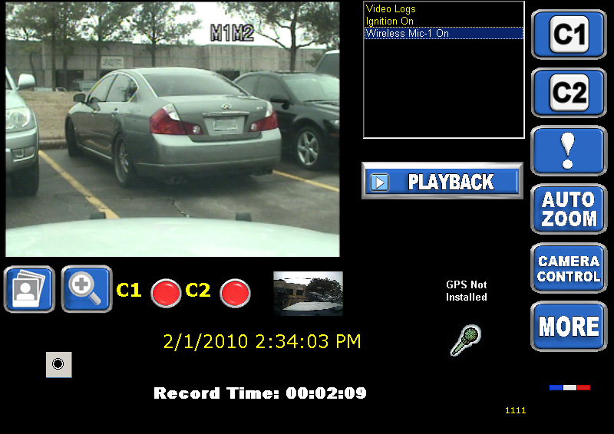

# Classify Recordings with Event Types

If enabled, the Event Type screen displays immediately after the user stops a video recording. Classifying a recording with an event type helps the DVMS save the video and allows metadata and other details to be stored with the recording. Additionally, event types allow DVMS to save retention criteria for each video. The mobile recorder system returns to the Camera View screen and the wireless microphone returns to standby mode once the video has been linked to an event type. In instances where both cameras are recording, the system gives the user the option to carry over the event data to the secondary camera.

## Select an Event Type

*To select an event type, follow these steps:*

1. Tap the camera icon to stop recording.

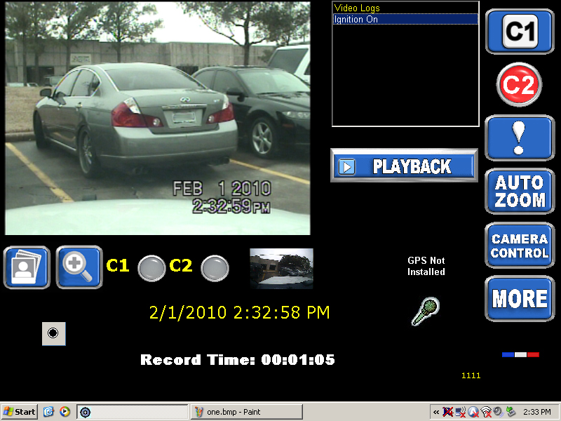

The **Event Type** screen is displayed.

1. Tap the appropriate event type to classify the video that was recorded. The Event Type will be highlighted in light blue when it is selected.

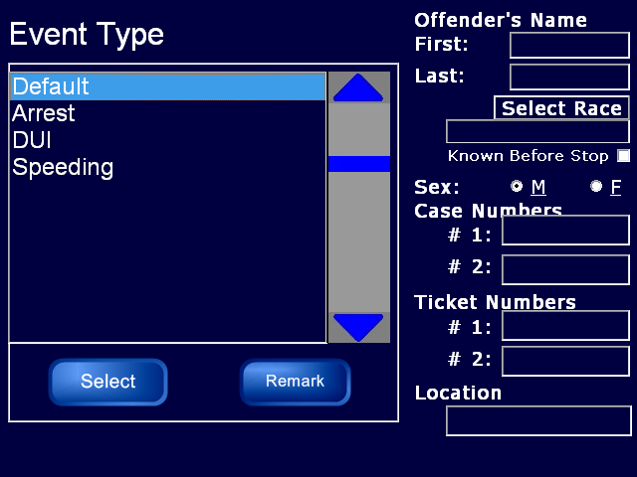

1. Tab **Select** to enter the event type.
2. Tap any of the text fields to display the virtual keypad.
3. Enter information associated with the recording, then tap **OK**.

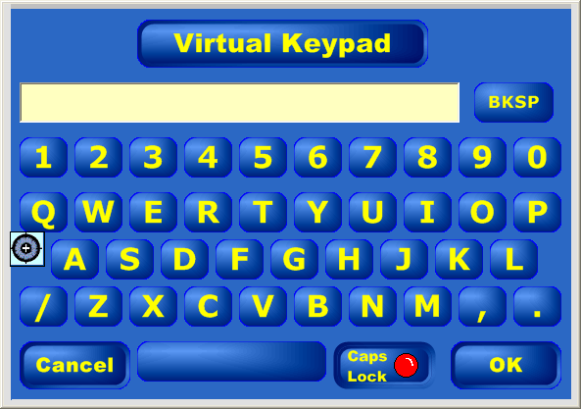

# Taking a Snapshot

Using the snapshot feature will take a JPG freeze frame image of the video displayed on the preview screen. A preview of the snapshot will be displayed immediately beneath the snapshot icon for 15 seconds. This feature works for any camera installed on the system, but only the camera view shown on the preview screen is available for snapshot.

*To take a snapshot while recording a video, follow these steps:*

1. Tap the Snapshot icon.

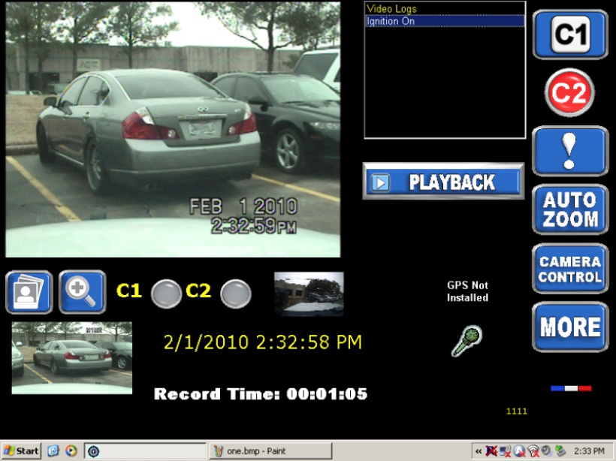

1. Tap the preview that appears beneath the Snapshot icon to enlarge the snapshot.

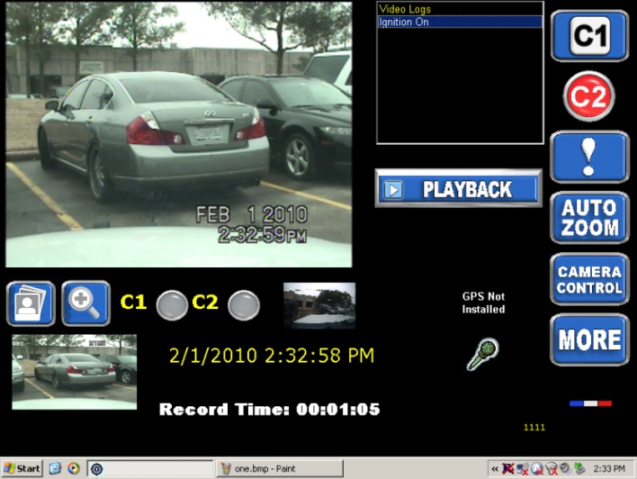

**NOTE**: The snapshot preview will be displayed for approximately 15 seconds.

1. Use the arrow keys to scroll through the snapshots saved.

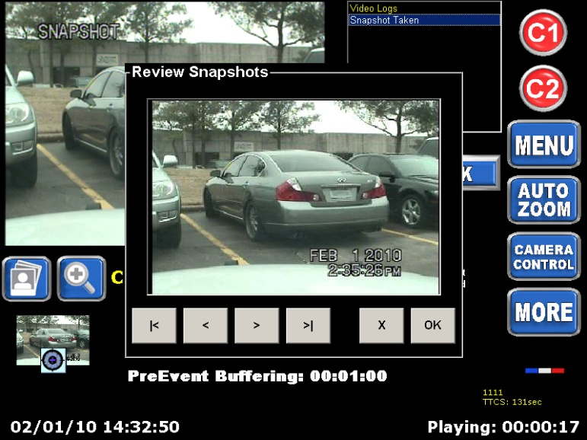

1. Click the **X** button to delete a snapshot.
2. Click **OK** to return to the **Camera View** screen.

# Bookmark a Video

Bookmarks are used to mark points in a video that the reviewer or user feels are significant. Bookmarks also allow users to quickly locate these significant points of videos during a review.

*To set a bookmark, follow these steps:*

1. Start a video recording.
2. Tap the **Bookmark** icon on the right side of the screen.

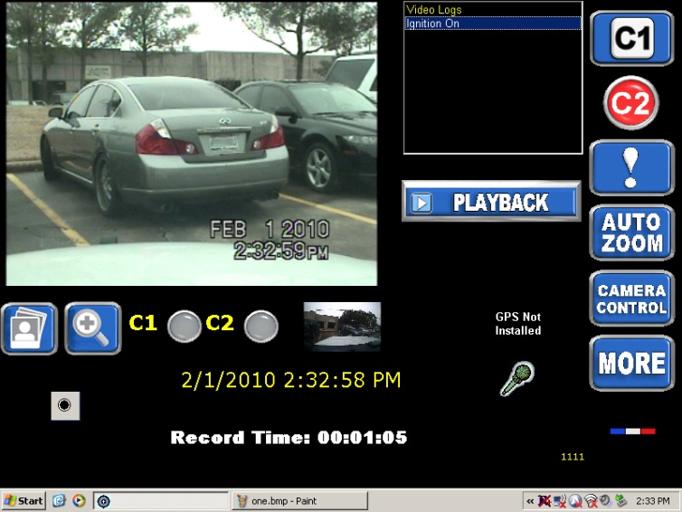

An entry will be displayed in the Video Log.

**NOTE**: The Bookmark icon is not displayed until the mobile recorder is actively recording.

# More Functions

*To access additional system features/functions, follow these steps:*

1. On the **Camera** **Preview** screen, tap the **MORE** button.



The **Additional Functions** screen displays.

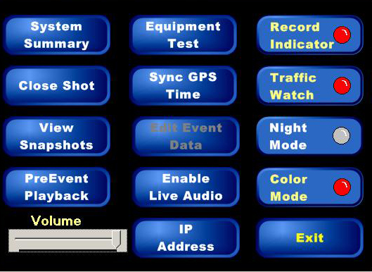

## System Summary

Tap the **System** **Summary** button to view a summary of the Mobile Recorder system.

The summary displays the total number of videos recorded, the total number of offender records entered, and the recording time left.

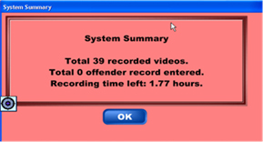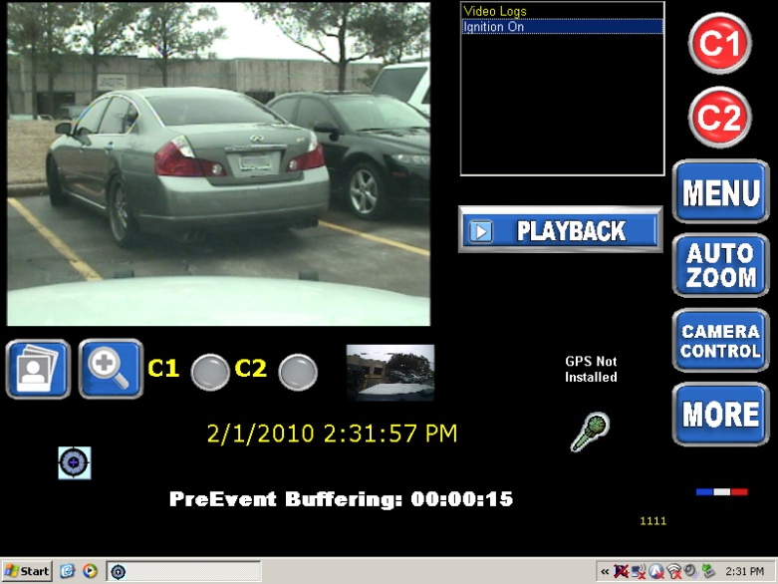

## Close Shot

This feature allows the camera to focus and take snapshots of objects closer than 1 ft away. Position the ID or other object approximately 1 inch from the camera’s lens, then tap the **Close** **Shot** button to focus the recorder beyond the vehicle’s windshield.

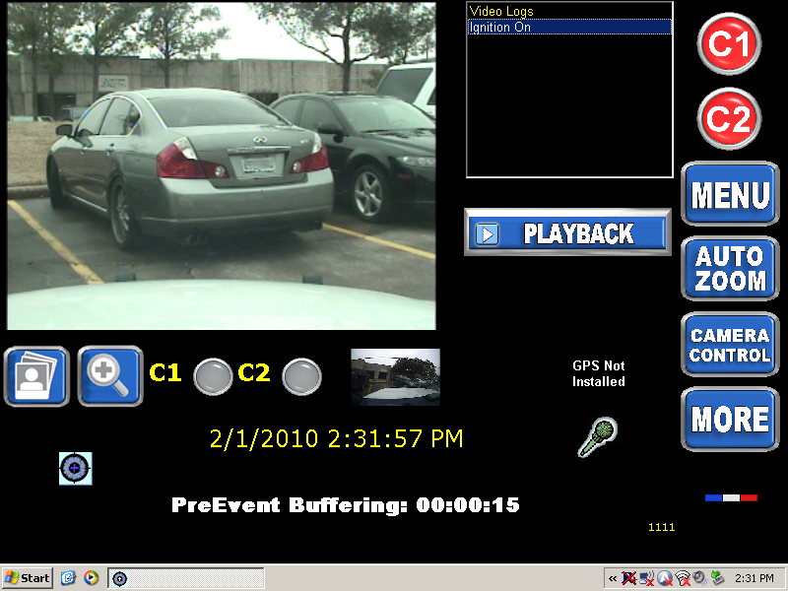

This point of focus ensures that rain drops or other debris on the windshield do not negatively affect the picture.

Users may use Close Shot mode to bring the focus point to within one inch from the camera for 5 seconds. During this time, a snapshot will be taken for later review.

## View Snapshots

Use this feature to review all snapshots created by the user.

1. Tap the **View** **Snapshots** button.
2. Use the arrow keys to scroll through the snapshots in the Mobile Recorder.

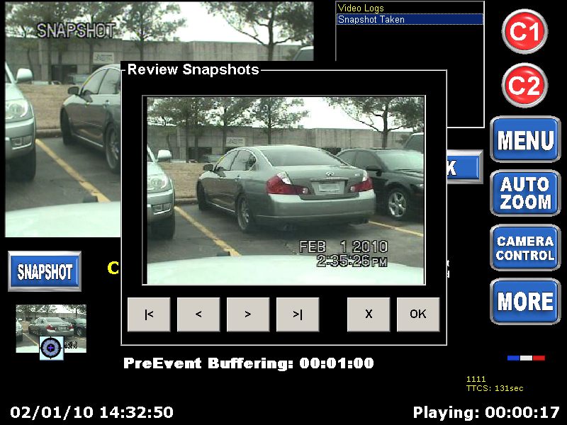

1. Click **X** to delete a snapshot.
2. Click **OK** to return to the **Camera View** screen.

## Pre-Event Playback

Use this feature to playback and/or extend the pre-event video.

1. Tap the **Pre-Event Playback** button.

Pre-event buffer, or the length of video that will precede a recording when the record icon is activated can be adjusted, but only prior to a recording.

Another useful feature of the pre-event playback is a feature that allows the users to go back to any point in time that occurred since that user logged onto the mobile recorder system. The pre-event buffer starts at the time a user logs on or switches users.

1. Tap the left and right arrow buttons to adjust the length of the pre-event section in minutes.

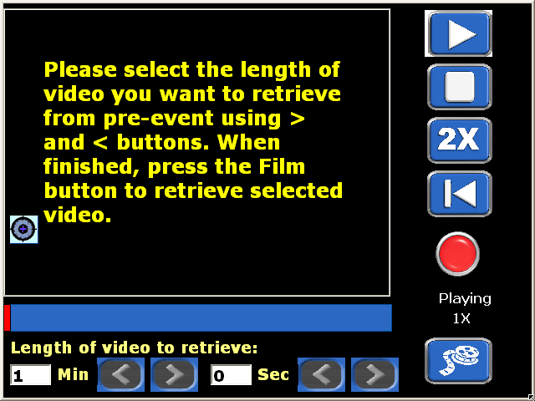

## Volume Adjustment

User the Volume slider to adjust the audio playback volume.

## Equipment Test

Use this feature to test equipment settings for the In-car unit.

1. On the **Additional Functions** screen, tap **Equipment** **Test**.

## Sync GPS Time

XXXXX

1. On the **Additional Functions** screen, tap **Sync GPS Time**.

## Edit Event Data

Use this feature to edit/add event data to a video while it is being recorded.

1. On the **Additional Functions** screen, tap **Edit Event Data**.

## Enable Live Audio

Use this feature to playback live audio from microphone through the speakers.

1. On the **Additional Functions** screen, tap **Enable Live Audio**.

## IP Address

Use this feature to view the IP address of the recording unit.

1. On the **Additional** **Functions** screen, tap **IP Address**.

## Record Indicator

Use this feature to toggle the red recording status LED indicator on the front of the front-facing camera.

1. On the **Additional Functions** screen, tap **Record Indicator**.

## Traffic Watch

Use this feature to toggle automatic zoom-out when recording is initiated for maximum field of view.

1. On the **Additional Functions** screen, tap **Traffic Watch**.

## Night Mode

Use this feature to toggle dimming of the camera interface to reduce unwanted

1. On the **Additional Functions** screen, tap **Night Mode**.

## Color Mode

Use this feature to toggle Color and Black/White (Infrared) mode on the front-facing camera.

1. On the **Additional Functions** screen, tap **Color Mode**.

# Obtain COBAN Support

COBAN offers the following ways to obtain support. Before you contact us, please have the following information ready to provide Support:

* Department Name
* Name of the registered contact with COBAN. If not registered within our system as an authorized contact, contact your project manager and request to be added to our contact list. Failure to do so may delay support assistance.
* Best contact number and preferred contact time
* Error Code/Description of issue you are experiencing
* Troubleshooting steps already taken

*To obtain COBAN support:*

**Call** support at **281-925-0488**, then select **Option 2**. You can hold for immediate assistance or leave a voicemail for COBAN Support to respond as soon as possible.

*Mon-Fri 8:00am to 6:00pm Central Standard Time (CST)*

**Email** Support at hwsupport@cobantech.com and include a detailed description of the issue you are experiencing. Also include any troubleshooting steps you have taken to resolve the issue. Support may request additional information or troubleshooting.

**Submit a Ticket** via our Website at<https://www.cobantech.com/support> and provide a good description of the issue you are experiencing and what troubleshooting steps have been taken in the comments section before submitting the form. Support may request additional information or troubleshooting.

**Search our knowledge base** at <http://kb.cobantech.com/> for resolutions to known issues, documents, manuals and more. Login is required for access to COBAN's knowledge base. If you do not have login credentials, please request one from support at hwsupport@cobantech.com. Ensure you are a registered COBAN contact before requesting access.