  - Locking a student record

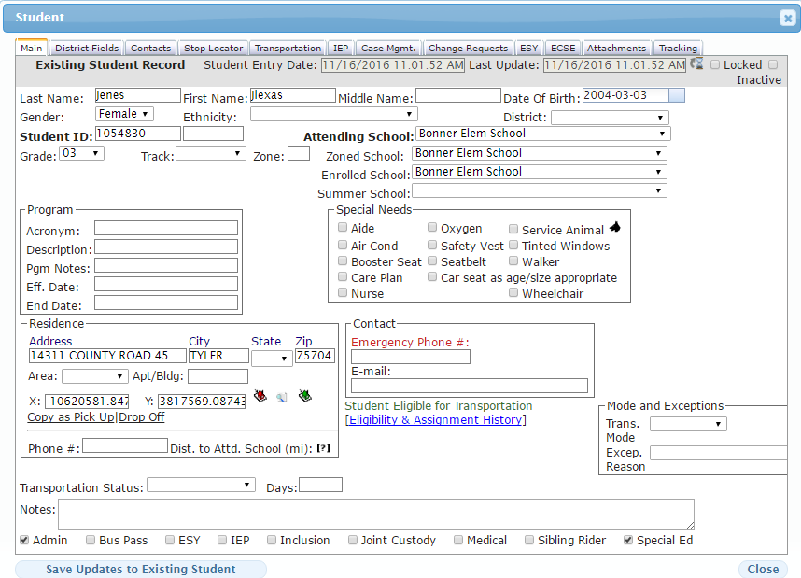
2
1

1 -
- Locked – this feature is designed to lock down a student record from being run (modified) through the nightly download task.
- Inactive – this feature when selected will inactivate a student record manually.
2 -

- Admin – (in addition with the Locked feature) would allow a GenEd Student record to be locked down without having to assign them to a SpEd category.
- Special Education – this flag will lock down a student record (prevents modifications to a record if a nightly download is implemented) from the nightly task.

Examples of why a student record

SpEd students would be a general reason for a record to be locked down for a router to manually maintain the data.

