  - Daily Router Check List

Nightly Download (Student Data from the Student information System)
- New Student Data
- Modified Existing Student Data
- De-enrolled Student Data

**Student statistics will vary each time the task is performed.

The following 4 categories will provide reports that will supply what data was modified in a student record:

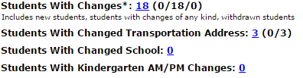

A description will be provided that explains all data modifications that occurred, the data updated is determined by the districts transportation office. (New students, existing students and withdrawn students)

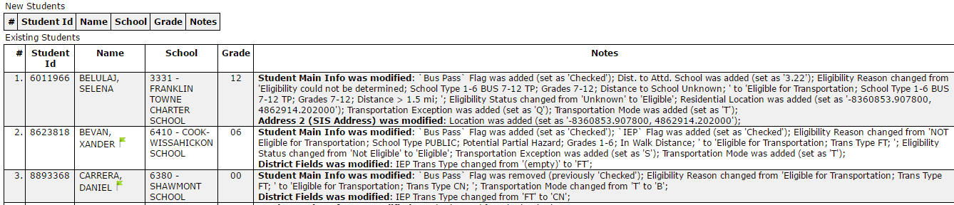

In the notes field, a user can verify the data changes are accurate.

Review and confirm stop assignment and eligibility for transportation
- Eligibility for Transportation – verify the results of this automated task under the Data Refresh tab from the Main dashboard in Compass.

There are 5 categories Compass will generate reports for:

**Attendance and Walk boundary data must be supplied to Seon prior to the setup of this configuration.

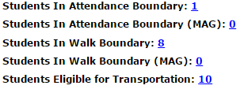

Results of these categories will vary upon each execution of the automated task.

A report will allow a user visibility of the results and reasoning of how the student transportation record was modified.

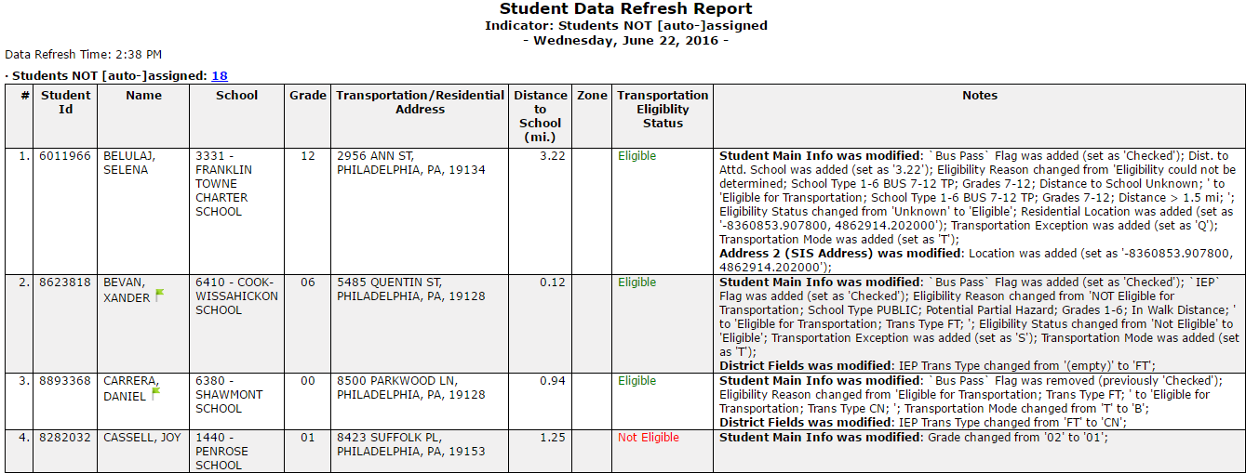

Review Stop assignment
- A user can confirm the results from the stop assignment (automated task) under the Data Refresh tab from the main menu dashboard.

There are 5 categories Compass will generate reports for:

**A report will allow a user visibility of the results and reasoning of how a student was assigned to the correct stop based on the district assignment process.

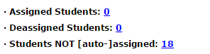

Review the Dashboard

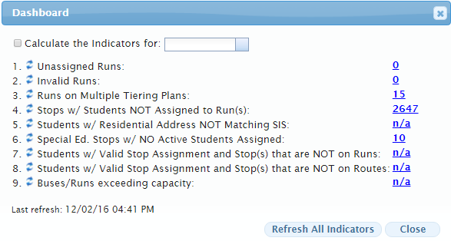

Below is a description of each category displayed in the Dashboard Menu:

1. Unassigned Runs: unassigned runs are runs that have no Route assignment
2. Invalid Runs: runs become invalidated for several reasons
3. Runs on multiple tiering plans: Runs that have multiple route assignments
4. Stops w/ students not assigned to Run (s): stops (with students assigned) that have no bus assignment
5. Students w/ Residential address not matching SIS (student information system)
6. Special Ed. Stops w/NO active students assigned: Sped stops that have no student data
7. Students w/ valid stop assignment and stop that are NOT on Runs
8. Students w/valid stop assignment and stops that are NOT on Routes
9. Buses/Runs exceeding capacity: Buses or runs that are exceeded in passenger capacity

Transportation Action Request TAR (Report included)

- A Transportation Action Request allows a user to see all district requests submitted to modify or change transportation information for a student.

- Select the filter called “With Open SSD Request(s), this will generate all student records that contain an OPEN request for transportation modifications.

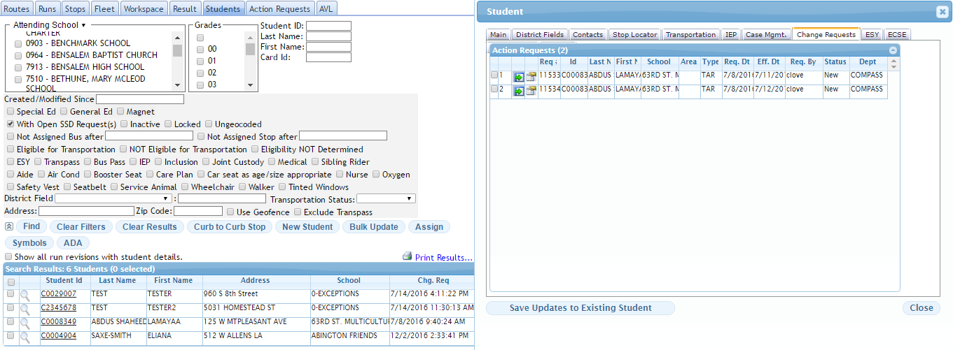

Under the Change Request tab (located in student transportation record) a user can process the requested changes and update the student record.

The edits/modifications will be made in the below screen:
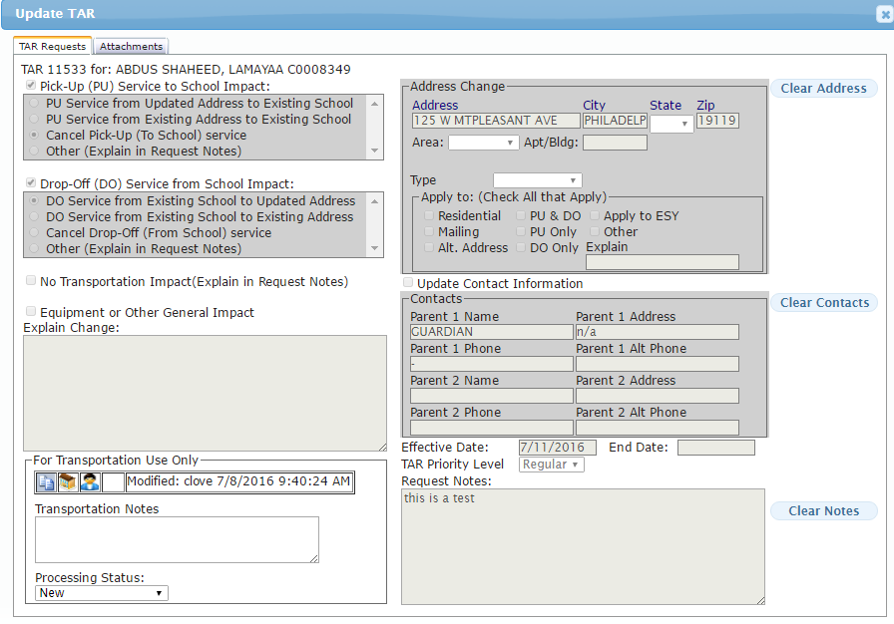
Action Requests supplies another view for a more detailed view of change requests. (Located under the main menu dashboard)

