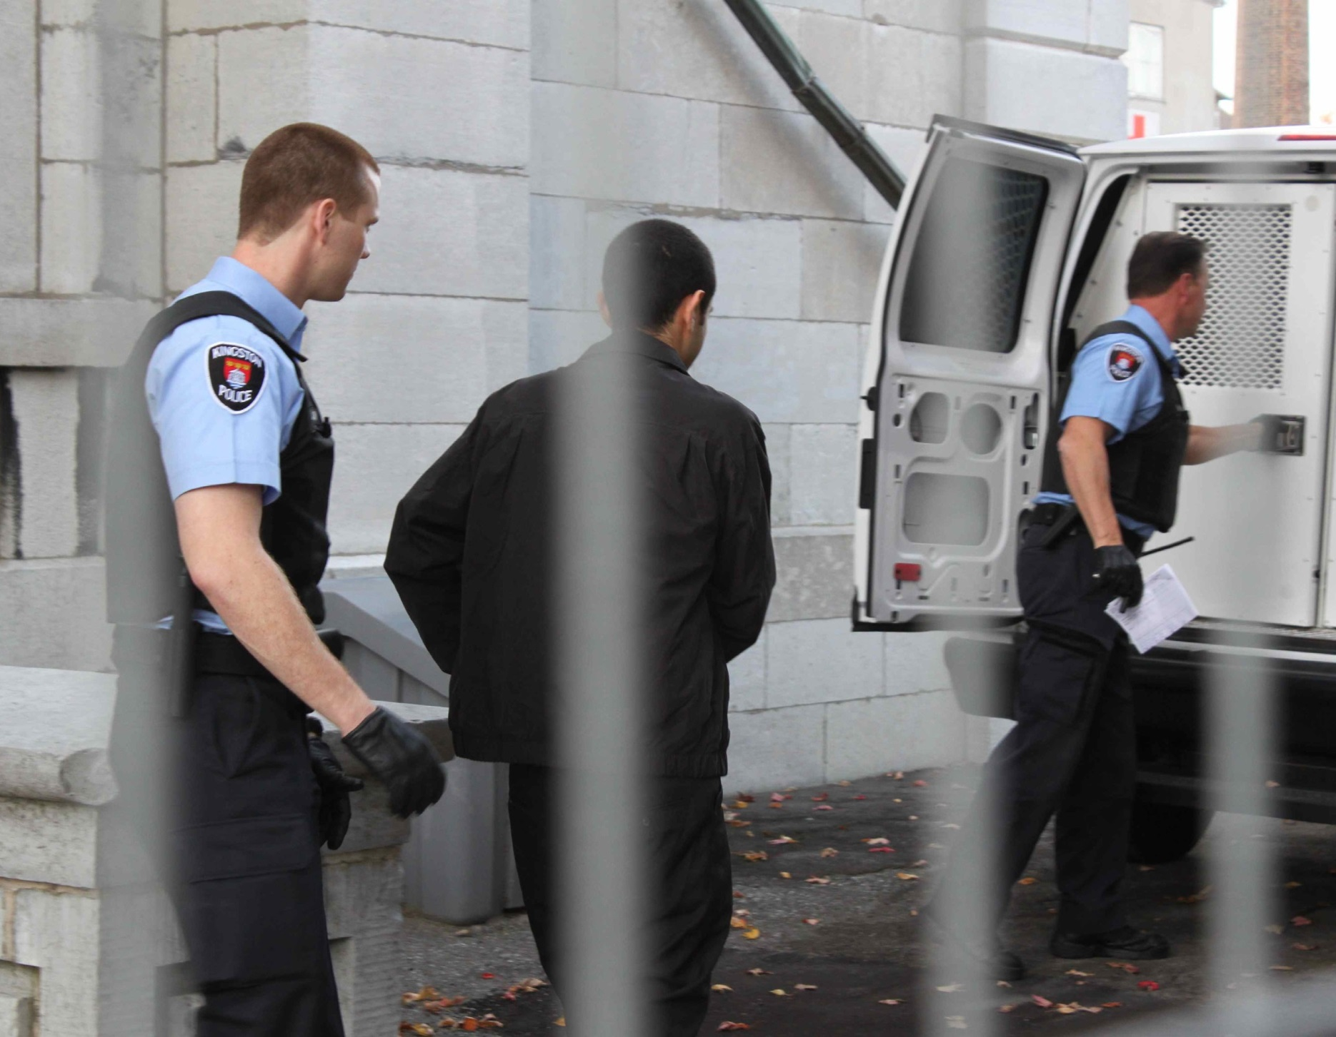
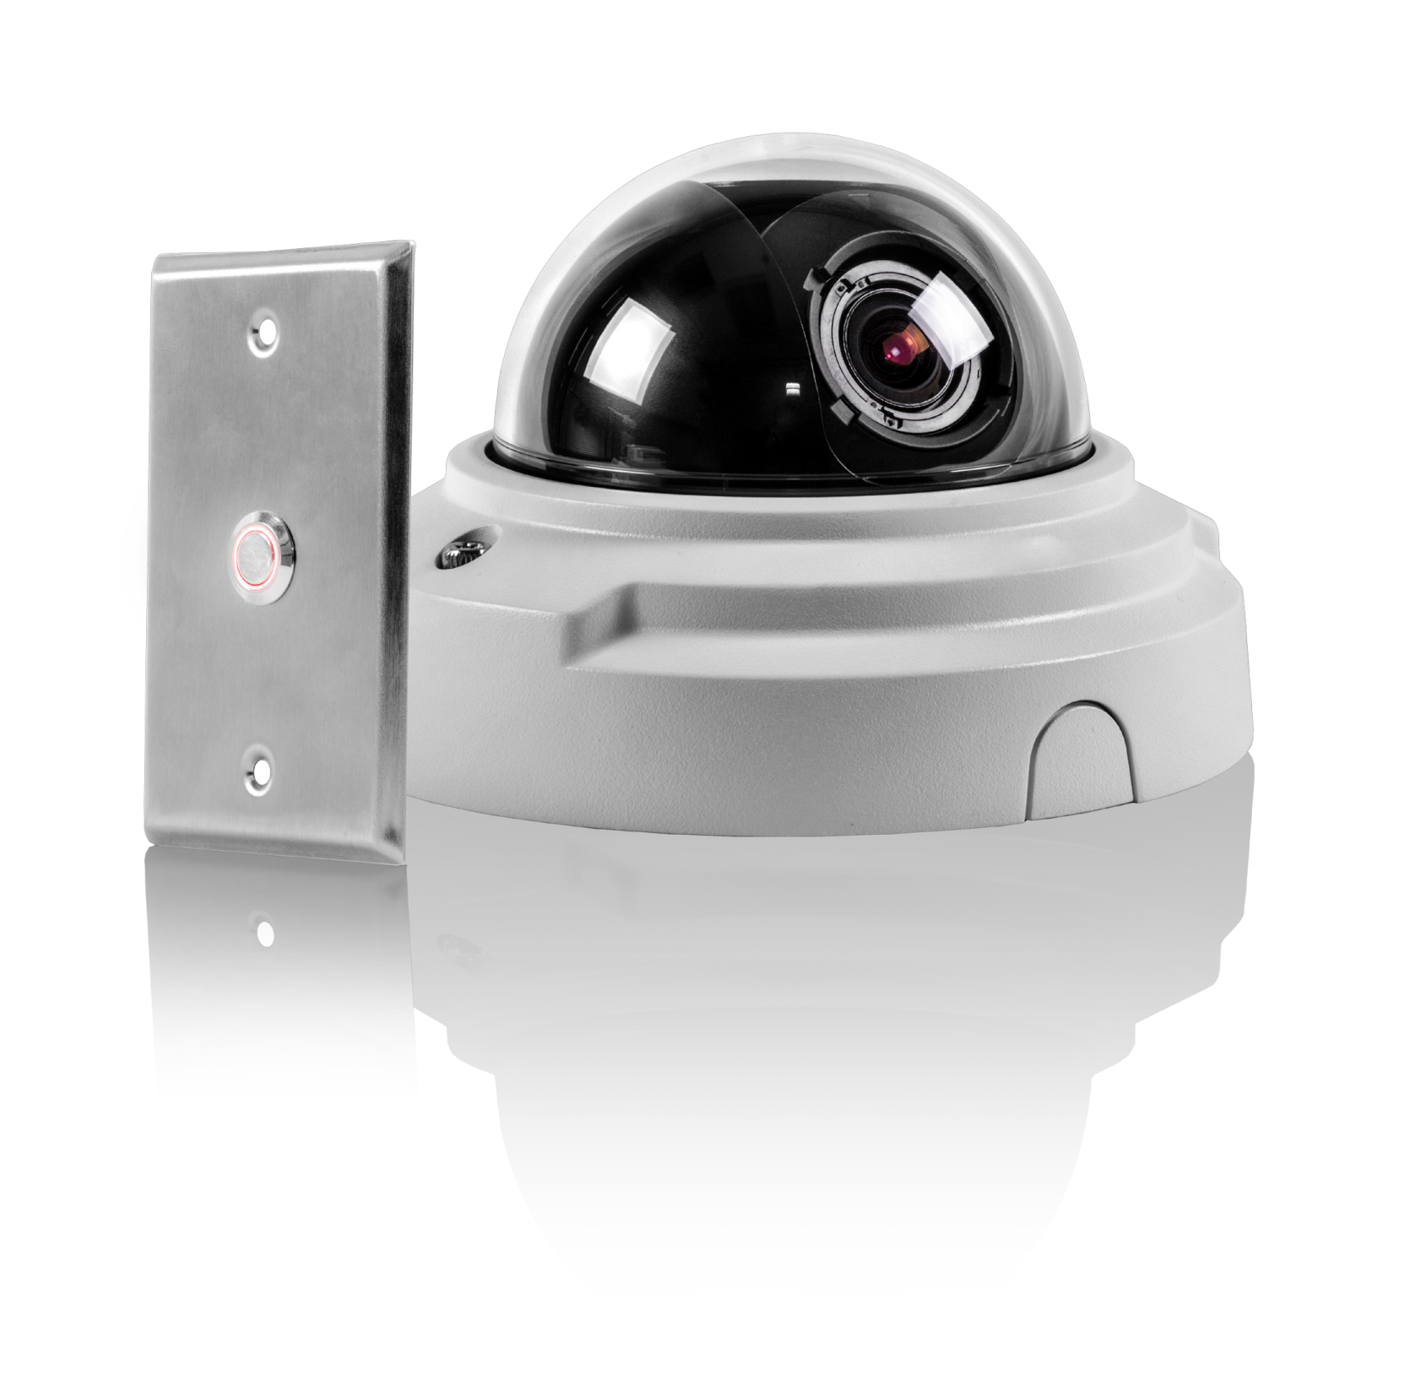
Admin Guide
(DVMS Integrated)
IP Interview Room

IP Interview Room with DVMS Intergration
- Obtain the url and port number to login to Coban Command Center.
- Type in the address into a browser.
- You will be taken to the login page for your Coban Command Center.
- Login to Coban Comman Center with your user credentials.
- NOTE – Windows Authentication is not supported in Integration Mode.
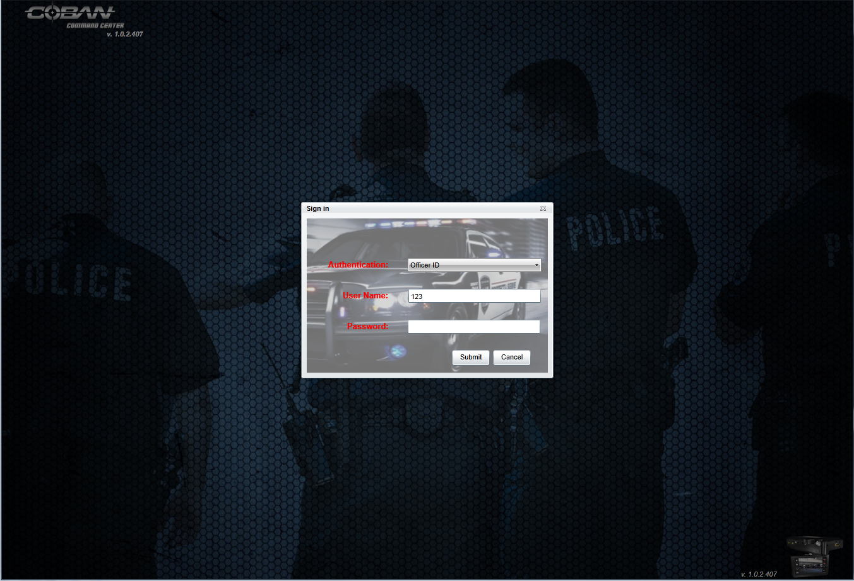
- Login to Coban Comman Center, making sure you have admin permission to perform the following tasks.
- Once you are logged into Coban Command click on the “Admin” link.

- Once on the “Admin” Page click on the “Roles” tab.
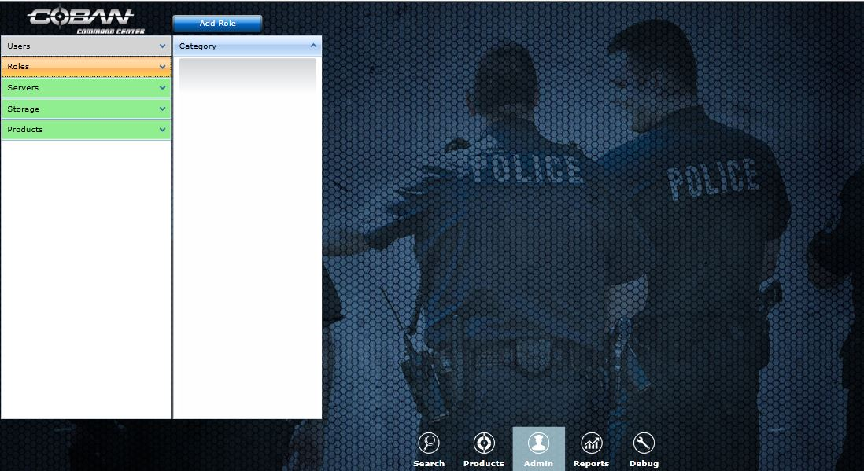
By default there will be 3 roles created. 1. Admin, 2. Officers, 3. Supervisors.
For Interview rooms leave the Admin role as is and remove the officer and the Supervisor roles.
To Remove the Officer Role right click Officer under the Roles Tab and select Remove Role.
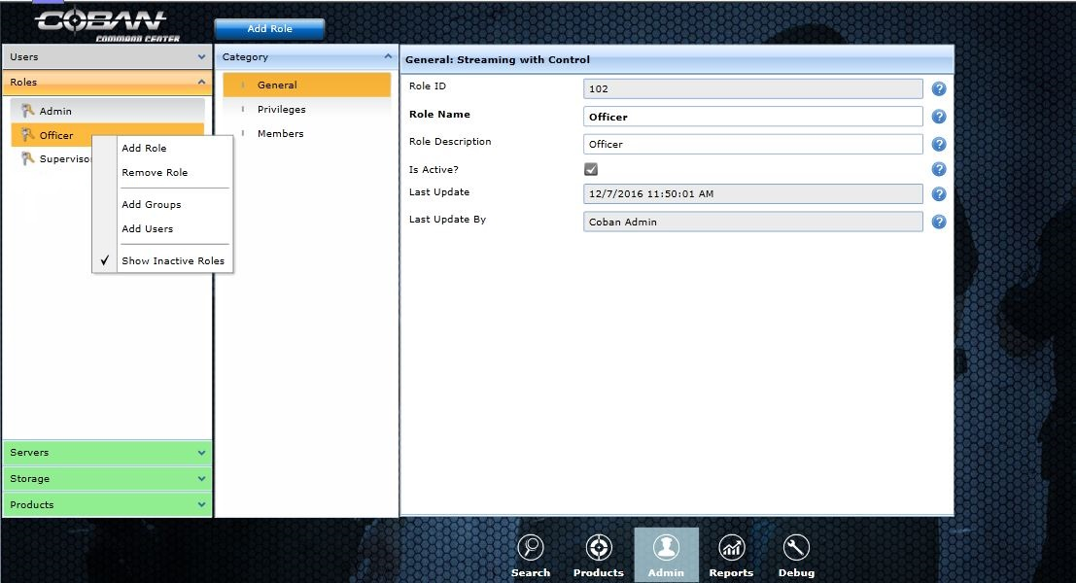

Step 1 - Next create a streaming Role.
Click on Roles then select Add Role Tab from top and Name the role. Give it a description and select ok at the bottom.
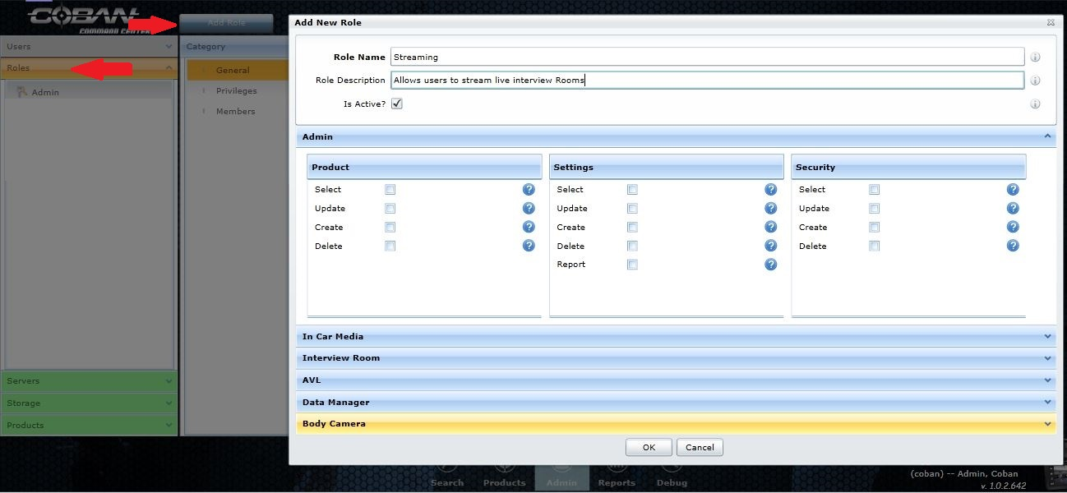
Step 2 - Next select the new role you created and from the Category section select Privileges, and from the right side select Admin.
Under the Admin section of the Privileges make sure all check boxes are clear.
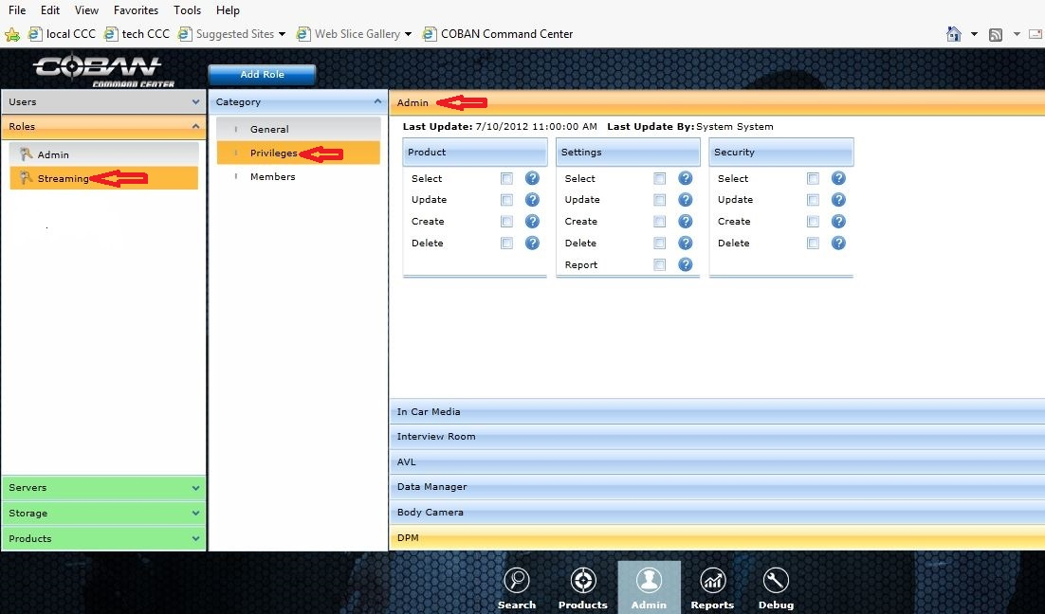

Step 3 - Select the In Car Media Tab and clear all checkboxes of the “In Car Media” Privileges
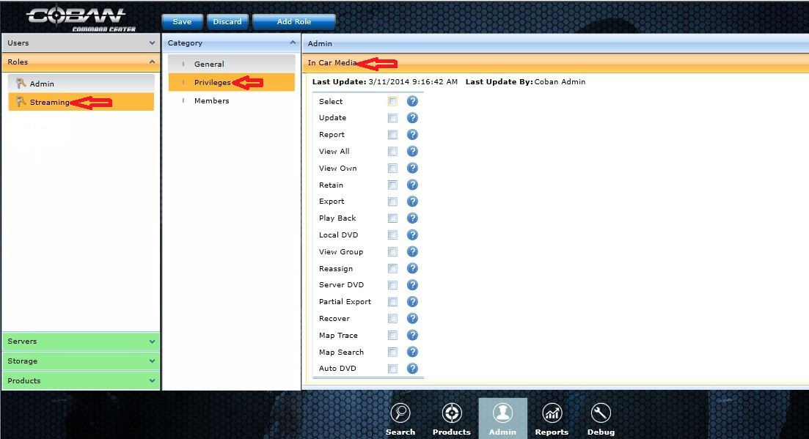
Step 4 - Select Interview Room Privileges tab and select under Camera (View Own, View All, Playback). Next under the Room tab check the select box.
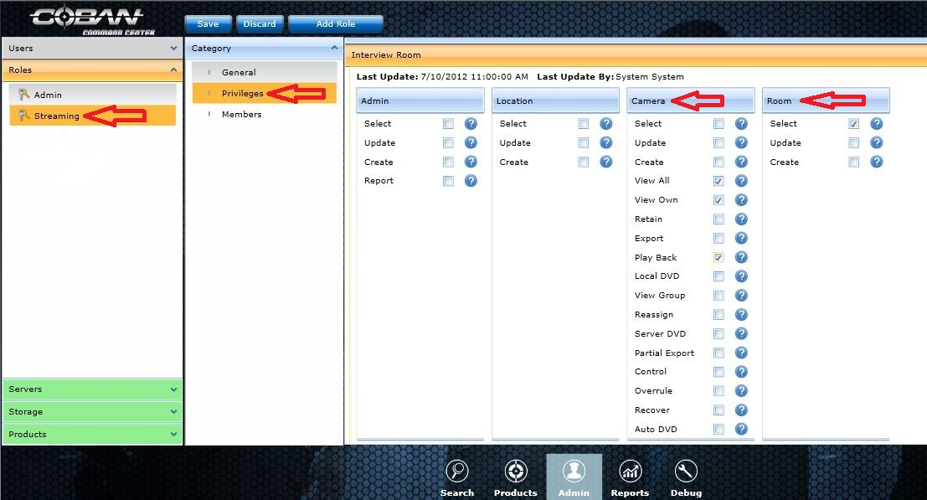

Step 5 - Select Data Manager Tab and clear all boxes.
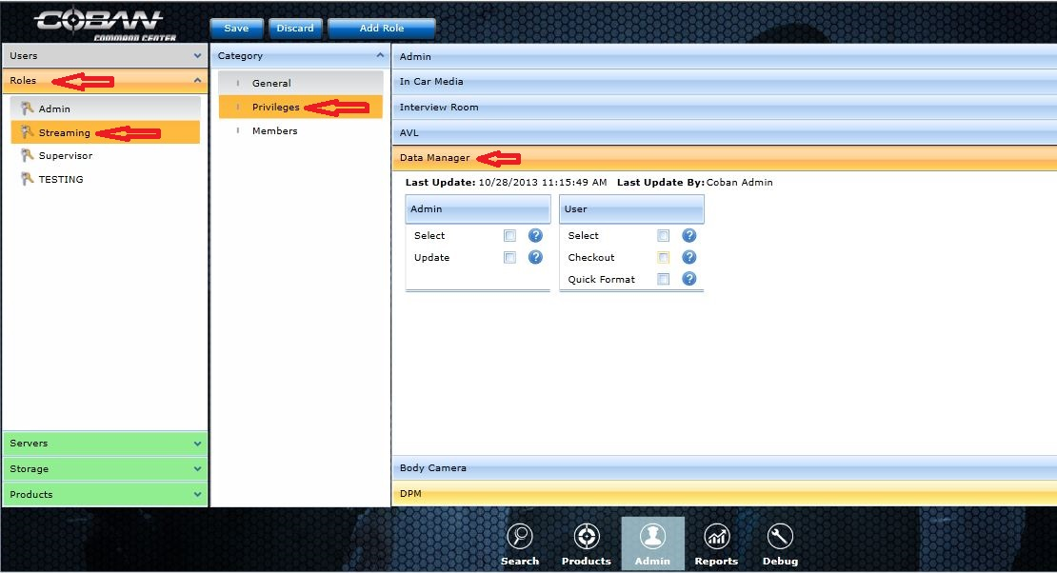
Next create a role called Streaming with Control.
Repeat the steps 1 – 5 above with the exception in the Interview Room Tab, include the control Check Box and the overrule right.
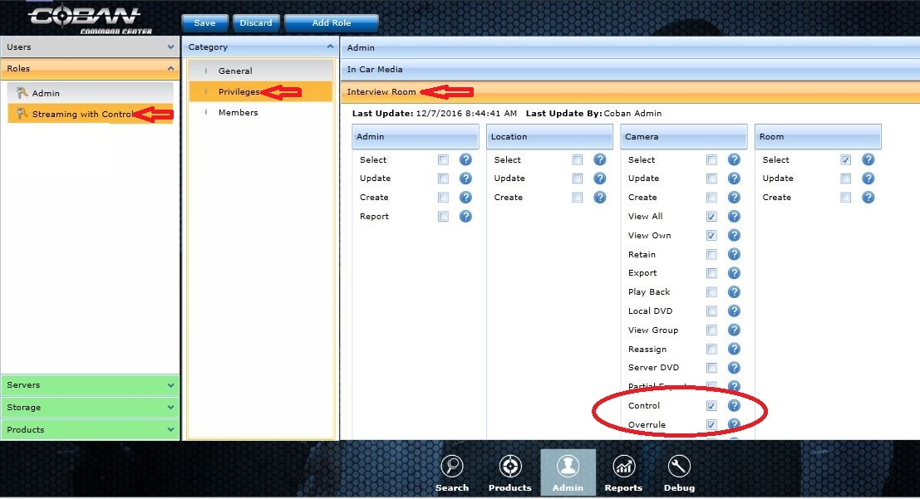
Once the Roles are created we need to add all users to a role. First select the Admin Role, Members, and then select from the top Add Users. Check each box next to all Admin users.
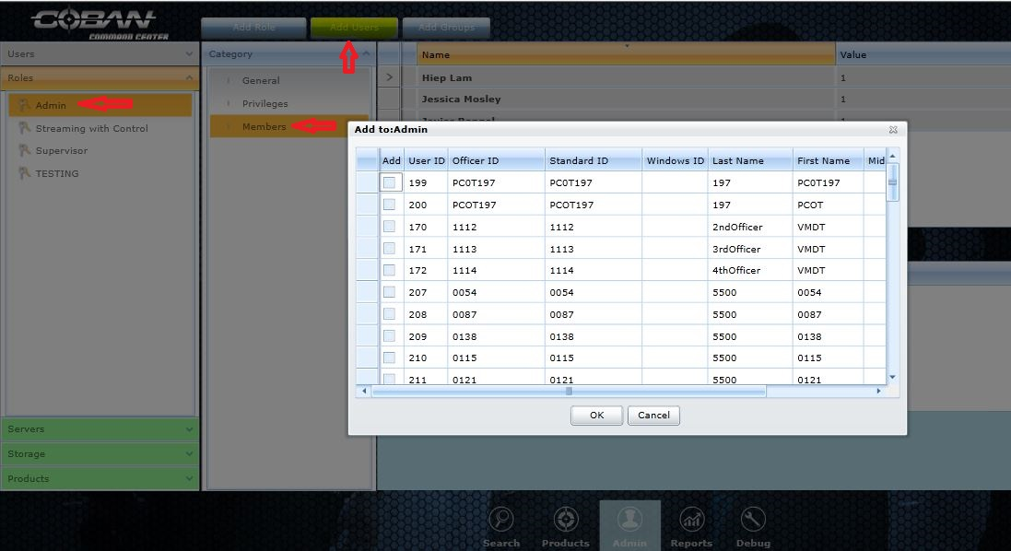
Next add all users to the Roles you just created. If you want someone to be able to view from their work station but not start recording add them to the Streaming Role. If you want them to be able to start a recording from a workstation add them to the Streaming with Control Role.
Viewing and Recording Live Interviews
Select the Products tab at the bottom of the Page. Then select the Interview Room tab on the left.
Note all users except Admin will only have the Product tab.

- Select the room you wish to view.
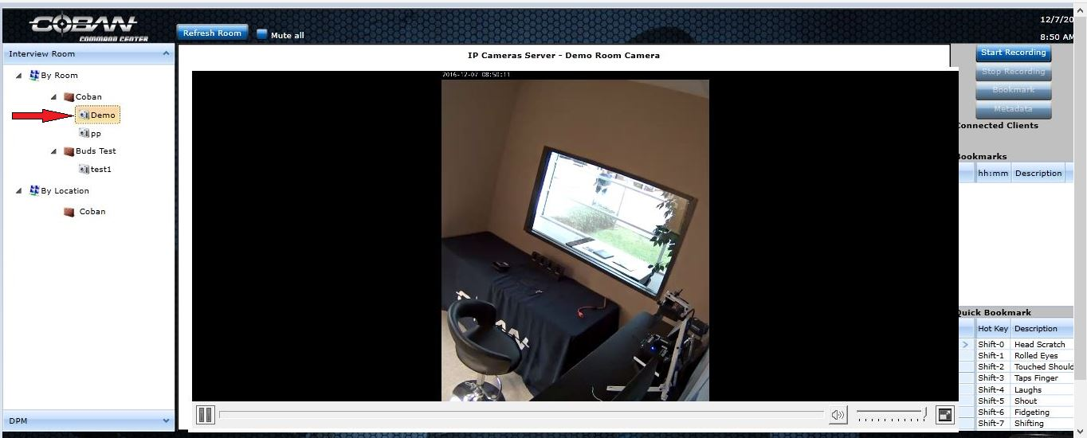

- You should now see a Live View of the selected room.
Note: If the live view does not appear click the refesh button and wait a few seconds.
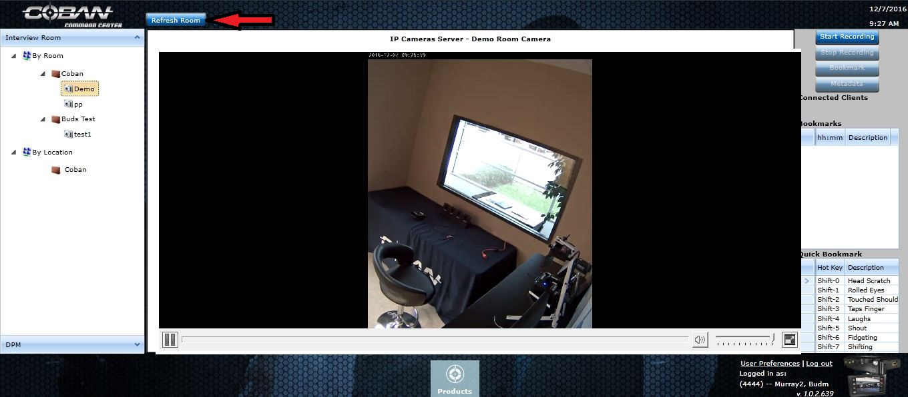

- To enable or disable live audio, click on the box labeled Mute all.

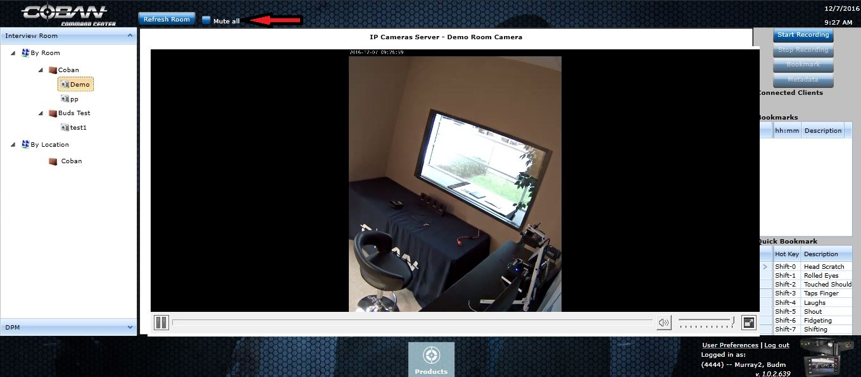
Recording within Coban Command Center Interview Room
- From the camera view, click Start Recording in the upper right hand corner.
- Note – Only users that are assigned to the Streaming with control will have access to the start recording button.

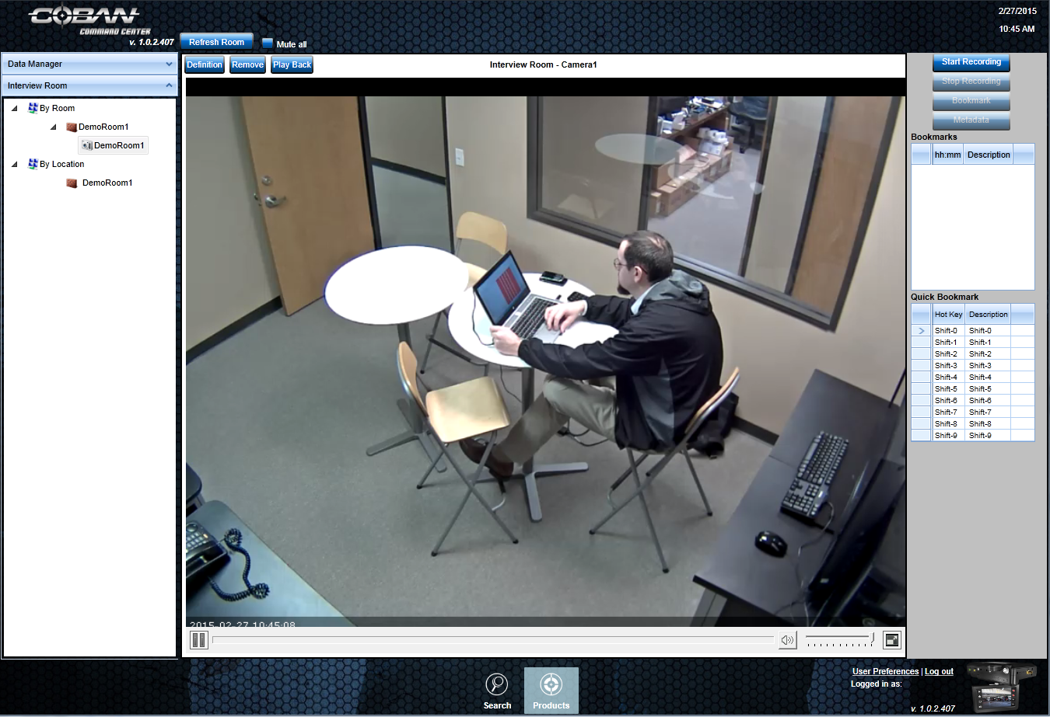

- A pop-up will appear for Metadata. Select the Event Type, Enter case number, and Enter Suspects Name
- Click Save to save the changes. Note – Before recording can begin an event type, suspect name and case number must be entered and Saved.

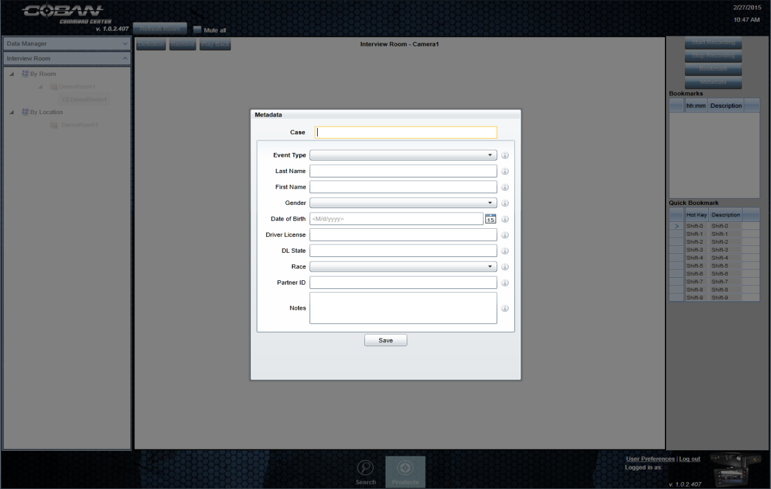
- When entering new case number and selecting ok the system will let you know this is a new case number. Select Ok.The next screen will allow you to keep the entered case number or allow you to correct the case number.
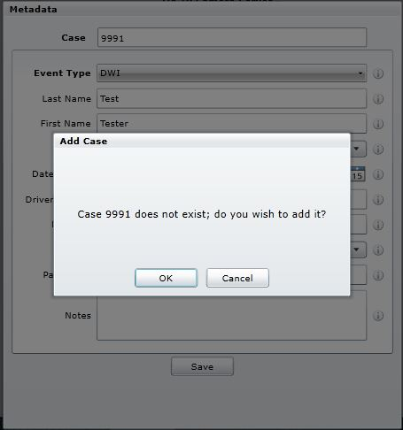

- The next screen will allow you to keep the entered case number or allow you to correct the case number. Select OK
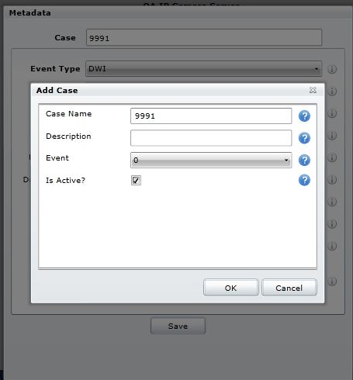
You may get a warning below that means that the event you selected, (in this case DWI with retention period of 90 days but the case number is already assigned a event selected with a longer retention period.
If you select ok on this screen it will match the event number assigned with this case number.
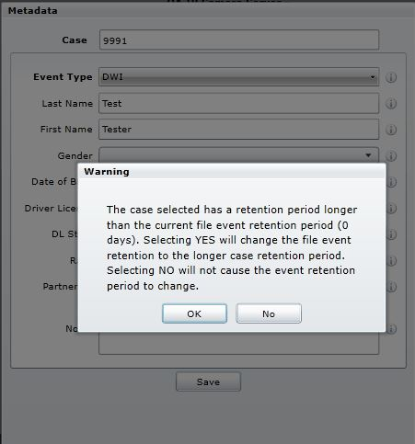
- Once you have saved the changes, the grayed out buttons will be available to select.
- Stop Recording, Bookmark, and Metadata.
- When you click Bookmark, you will see the bookmarks listed under the recording options to the right of the camera preview. You can also select a quick book mark. Book Marks allow you to find this location while playing back the video at a later date.

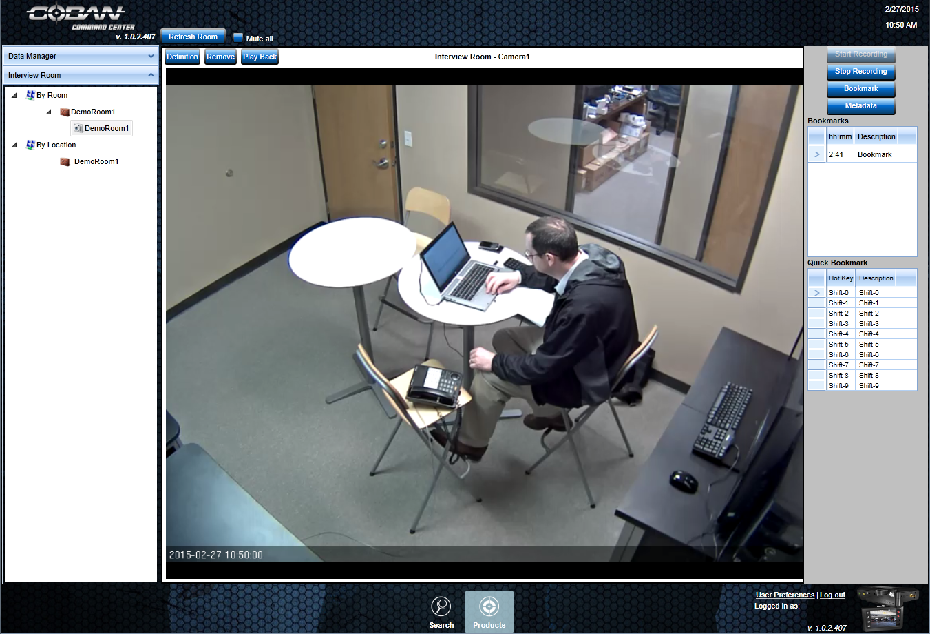

- Once the recording is complete, click Stop Recording

Once video is stopped, it will be processed and moved to DVMS. Depending on Video size the time it takes to process and move will vary from a few minutes to 20 min for a 2 hour long video.

- Searching for a Video - Note in integration mode (Using IP Interview Room with DVMS) all video access is performed in DVMS and should not be performed in COMMAND Center.
Advanced Setup using Scope
Scope allows you to limit streaming and control to specific camera groups.
In order to use Scope you must set up a Server for each camera Group you want to manage independently.
To access Scope on a Camera group, navigate to the Admin Tab at the bottom, Select Server on the left, then select under app the server that represents the camera group you want to limit access to. Select Scope under the category.
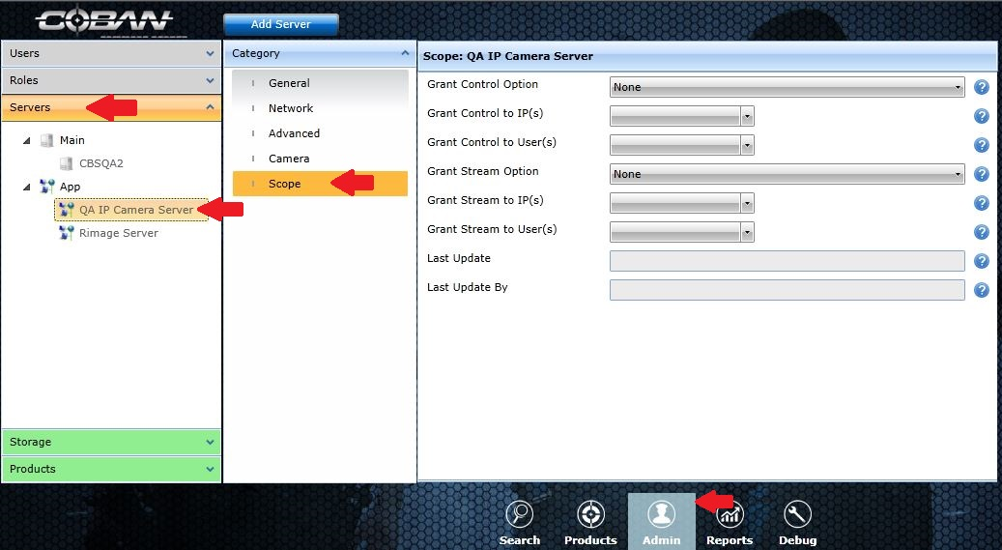
Once you have selected scope for the camera group you want to limit access to you have many choices. You can limit streaming or control to specific users (note these settings over ride role access settings) or work stations, or both. Warning ! if you change the grant control option or grant streaming option from the default setting of NONE, you must Identify the Ips or users you want to have acess to these cameras.
If you want to limit user access for Control, select the drop down and select users.
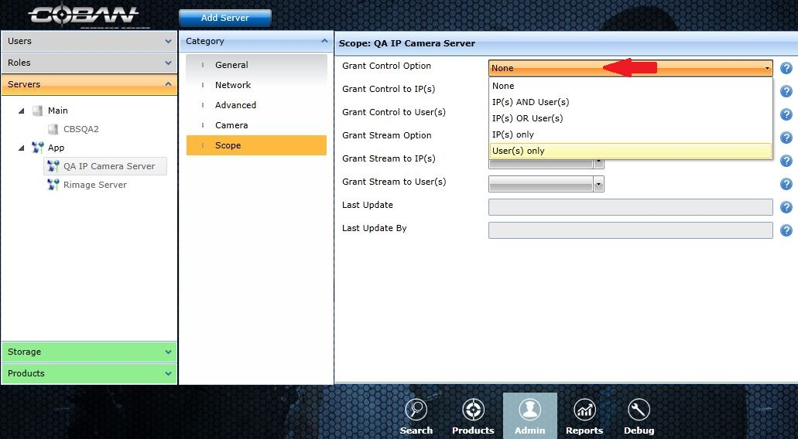

Once you have selected users only, no one will have control access until you grant them access.
Click on the drop down box labeled Grant Control to Users.
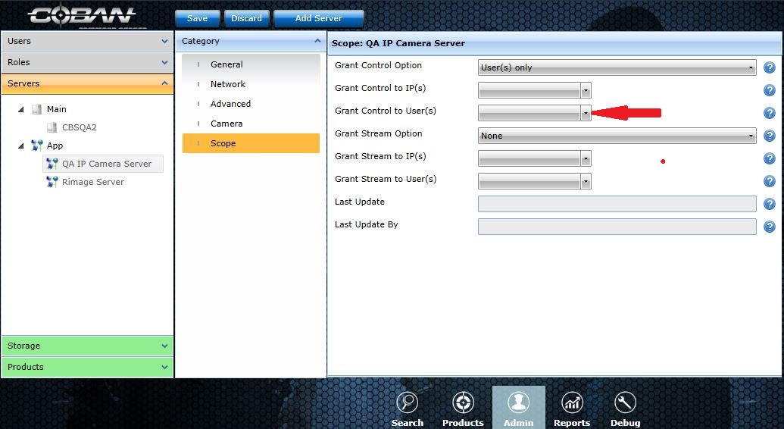
A pop up box with All users in system will appear.
Click on the box next to the user ID you want to grant access to and a check will appear in the box. Continue until you have all users that should have control access checked. And select ok.
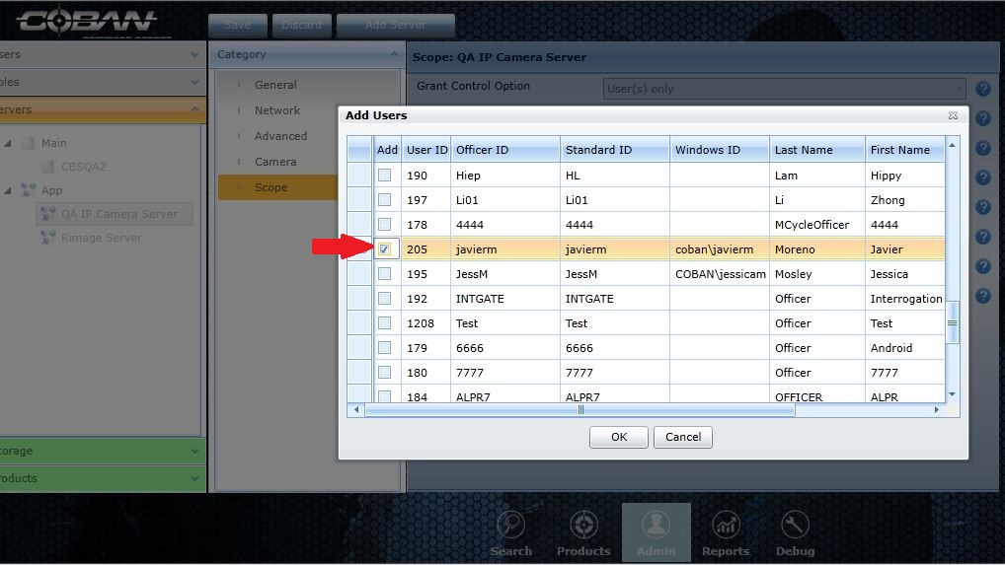
If you wanted to limit access to specific users and location, you would have to select users and IP in the grant control option.
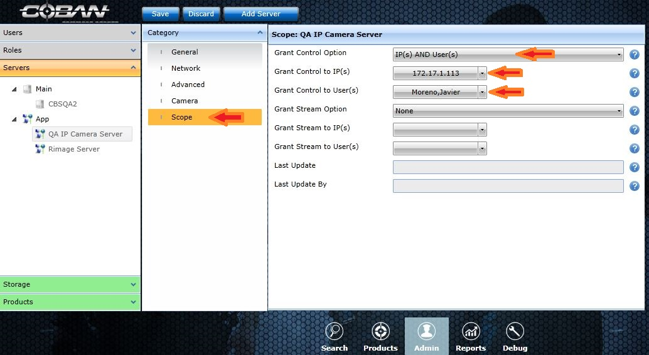
In the above example only Javier working at the work station assigned with the IP of 172.17.1.113 will have control of this camera group.

