

*COBAN FOCUS H1 In-Car Video System   
User Guide*

*v. 1.0.2*

COBAN® Technologies Inc.

11375 West Sam Houston Parkway South, Suite 800

Houston, Texas 77031

Tel: 1-281-925-0488

Fax: 1-281-925-0535

<http://www.cobantech.com>

Copyright

THE SPECIFICATIONS AND INFORMATION REGARDING THE PRODUCTS IN THIS MANUAL ARE SUBJECT TO CHANGE WITHOUT NOTICE. ALL STATEMENTS, INFORMATION, AND RECOMMENDATIONS IN THIS MANUAL ARE BELIEVED TO BE ACCURATE BUT ARE PRESENTED WITHOUT WARRANTY OF ANY KIND, EXPRESS OR IMPLIED. USERS MUST TAKE FULL RESPONSIBILITY FOR THEIR APPLICATION OF ANY PRODUCTS.

THE SOFTWARE LICENSE AND LIMITED WARRANTY FOR THE ACCOMPANYING PRODUCT ARE SET FORTH IN THE INFORMATION PACKET THAT SHIPPED WITH THE PRODUCT AND ARE INCORPORATED HEREIN BY THIS REFERENCE. IF YOU ARE UNABLE TO LOCATE THE SOFTWARE LICENSE OR LIMITED WARRANTY, CONTACT YOUR COBAN TECHNOLOGIES REPRESENTATIVE FOR A COPY.

NOTWITHSTANDING ANY OTHER WARRANTY HEREIN, ALL DOCUMENT FILES AND SOFTWARE OF THESE SUPPLIERS ARE PROVIDED “AS IS” WITH ALL FAULTS. COBAN TECHNOLOGIES AND NAMED SUPPLIERS DISCLAIM ALL WARRANTIES, EXPRESSED OR IMPLIED, INCLUDING, WITHOUT LIMITATION, THOSE OF MERCHANTABILITY, FITNESS FOR A PURPOSE AND NON-INFRINGEMENT OR ARISING FROM A COURSE OF DEALING, USAGE, OR TRADE PRACTICE.

IN NO EVENT SHALL COBAN TECHNOLOGIES OR ITS SUPPLIERS BE LIABLE FOR ANY INDIRECT, SPECIAL, CONSEQUENTIAL, OR INCIDENTAL DAMAGES, INCLUDING, WITHOUT LIMITATION, LOST PROFITS OR LOSS OR DAMAGE TO DATA ARISING OUT OF THE USE OR INABILITY TO USE THIS MANUAL, EVEN IF COBAN TECHNOLOGIES OR ITS SUPPLIERS HAVE BEEN ADVISED OF THE POSSIBILITY OF SUCH DAMAGES.

COBAN AND THE COBAN LOGO ARE TRADEMARKS OF COBAN TECHNOLOGIES. THIRD-PARTY TRADEMARKS MENTIONED ARE THE PROPERTY OF THEIR RESPECTIVE OWNERS. THE USE OF THE WORD “PARTNER” DOES NOT IMPLY A PARTNERSHIP RELATIONSHIP BETWEEN COBAN TECHNOLOGIES AND ANY OTHER COMPANY.

ANY INTERNET PROTOCOL (IP) ADDRESSES AND PHONE NUMBERS USED IN THIS DOCUMENT ARE NOT INTENDED TO BE ACTUAL ADDRESSES AND PHONE NUMBERS. ANY EXAMPLES AND FIGURES INCLUDED IN THE DOCUMENT ARE SHOWN FOR ILLUSTRATIVE PURPOSES ONLY. ANY USE OF ACTUAL IP ADDRESSES OR PHONE NUMBERS IN ILLUSTRATIVE CONTENT IS UNINTENTIONAL AND COINCIDENTAL.

*COBAN FOCUS H1 In-Car Video System Installation and User Guide v1.0.2*

2018 COBAN™ TECHNOLOGIES. ALL RIGHTS RESERVED.

Revisions

|  |  |  |
| --- | --- | --- |
| 3/22/2018 | Initial draft | *V1.0.2* |

Table of Contents

Table of Figures 4

1 Introduction 5

2 Using the FOCUS H1 6

2.1 User Interface Overview 6

2.2 Log in to the H1 System 7

2.3 Recording a Video 8

2.3.1 Record Indicators 8

2.3.2 Start/Stop a Recording 8

2.4 Create a Bookmark 8

2.5 Menu Functions 9

2.5.1 Playback ICV Video 10

2.5.2 Playback BWC Video 12

2.5.3 Turn On/Off In-Car Microphones 13

2.5.4 Upload Video via Wireless 13

2.5.5 View FailSafe Videos 15

2.5.6 Take/View a Snapshot 16

2.5.7 Switch Officers 18

2.5.8 Shut Down the System 19

2.6 Working with System Settings 20

2.6.1 Access the System Settings 20

2.6.2 Turn On/Off Live Audio 21

2.6.3 Adjust the Volume 22

2.6.4 View Log File 23

2.6.5 Viewing the System Summary 24

2.6.6 Run a Diagnostic Status Report 26

2.6.7 Access Live Streaming Videos 27

3 Obtain COBAN Support 28

# Table of Figures

Figure 1: COBAN H1 Home Screen 6

Figure 2: LOGIN Screen 7

Figure 3: Virtual Keypad 7

Figure 4: Home Screen 8

Figure 5: Create a bookmark 9

Figure 6: Access menu functions 9

Figure 7: FREQUENTLY USED screen 9

Figure 8: Playback ICV videos 10

Figure 9: List of ICV videos 10

Figure 10: ICV video playback screen 11

Figure 11: Add/edit metadata for a ICV video 11

Figure 12: Playback a BWC video 12

Figure 13: Turn on/off in-car microphones 13

Figure 14: Upload videos via wireless 13

Figure 15: Upload screen 14

Figure 16: View FailSafe video 15

Figure 17: FAILSAFE VIDEO screen 15

Figure 18: Playback a FailSafe video 16

Figure 19: Take a snapshot 16

Figure 20: View a snapshot 17

Figure 21: SNAPSHOT LIST screen 17

Figure 22: Snapshot view 18

Figure 23: Switch officers 18

Figure 24: LOGIN screen 19

Figure 25: Shut down the system 19

Figure 26: Confirmation of shutdown 20

Figure 27: Access the system settings 20

Figure 28: SYSTEM SETTING screen 21

Figure 29: Turn on/off live audio 21

Figure 30: Adjust the volume 22

Figure 31: VOLUME CONTROL screen 22

Figure 32: View log files 23

Figure 33: LOG FILES screen 23

Figure 34: View the system summary 24

Figure 35: System Version screen 24

Figure 36: Failsafe & PenDrive summary screen 25

Figure 37: Current Status screen 25

Figure 38: GPS Info screen 26

Figure 39: Run a status report 26

Figure 40: RUN STATUS screen 27

Figure 41: Access live streaming videos 27

# Introduction

This document is intended for use with COBAN H1 In-Car Video System and contains instructions for using the COBAN H1.

COBAN manufactures state-of-the-art mobile data computers and digital video recording equipment for use in the public safety, utility and military community. In addition to innovative mobile computing devices and digital video technology, COBAN employs the latest communication, database, and storage technologies to deliver complete and scalable solutions to our customers, regardless of the size of the agency.

**DISCLAIMER**: Due to variations in vehicles, agency equipment requirements, and the placement of existing equipment, every installation in a public safety vehicle is unique. This manual assumes and illustrates installations in Ford Crown Victoria, Chevy Impala, Silverado and Tahoe, as well as Dodge Charger and Magnum.

The information contained herein is subject to change without notice. COBAN Technologies reserves the right to make changes to this product, has no obligation to update or keep current the information contained within, and assumes no responsibility for any errors or omissions that may be present in this document.

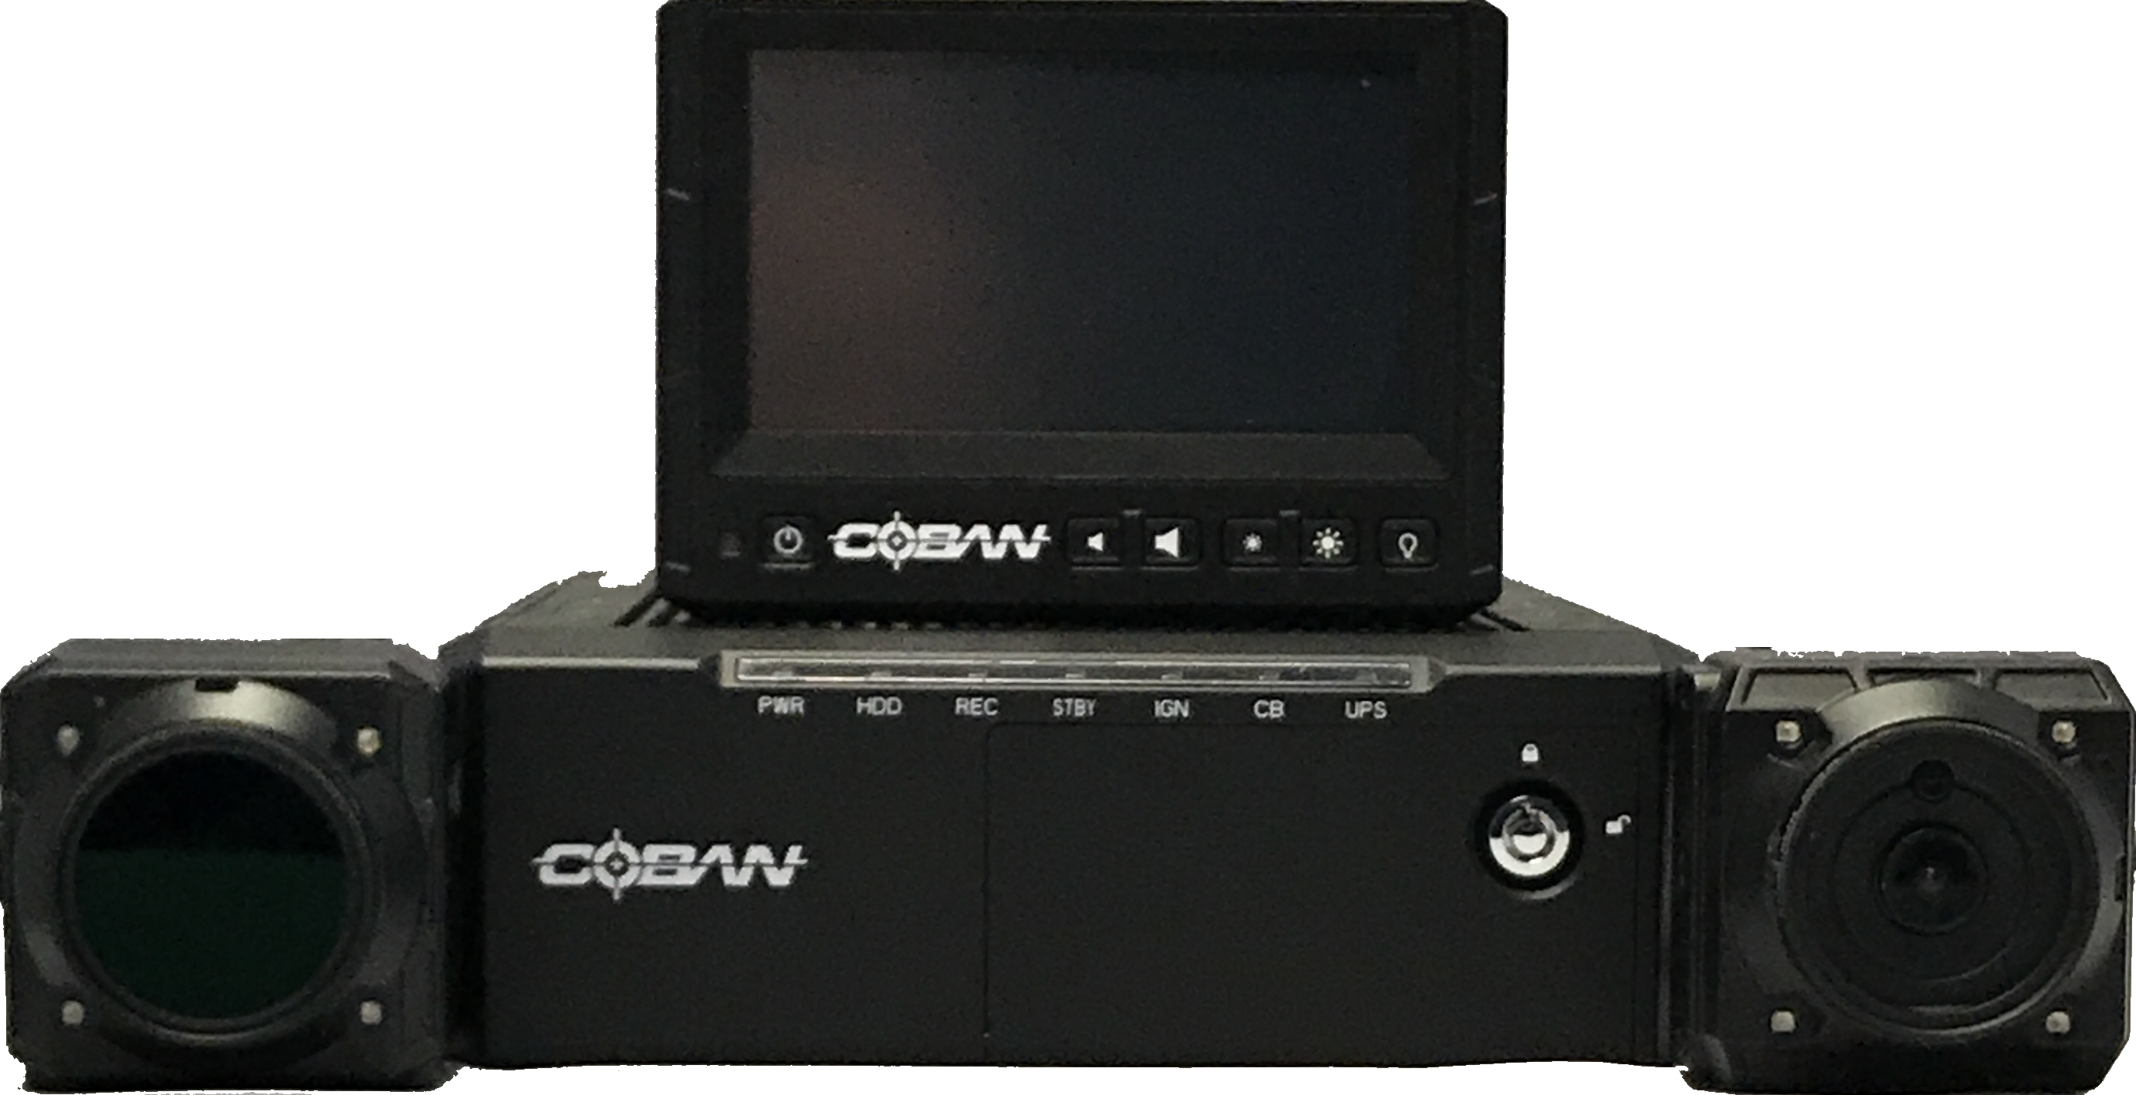

# Using the FOCUS H1

## User Interface Overview

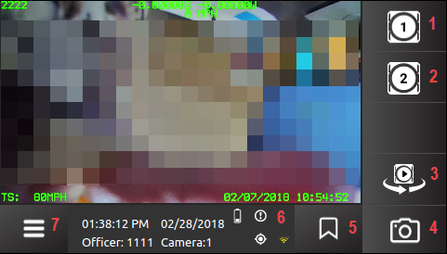

Figure 1: COBAN H1 Home Screen

|  |  |  |
| --- | --- | --- |
|  | **1 – Camera** **1** – Tap to start/stop recording on Camera 1. | |
|  | **2 – Camera** **2** – Tap to start/stop recording on Camera 2. | |
|  | **3 – Switch Live View** – This icon will rotate Camera 1, Camera 2, Camera 3. | |
|  | **4 – Snapshot** – This icon will take a JPG freeze frame image of the video during recording of the current live view camera | |
|  | **5 – Bookmark** – Select the bookmark icon to mark a spot in metadata for later review. | |
|  | **6 – Detail Display** – Displays current date/time, officer number, and the following: | |
|  | | System error   No GPS Lock  cid:image014.png@01D333B1.DA00A660 Power Loss   UPS Battery Power Low   cid:image016.png@01D333B1.DA00A660 Thumb drive almost full | |
|  | **7** – **Menu** – Provides access to additional system functions, including switch officer, equipment test, speaker configurations and system shutdown. | |

## Log in to the H1 System

Before each shift, users must log in to the H1 system using a valid user ID and password.

*To log in to the system follow these steps:*

1. Press the **Power** button on the H1 device. The **LOGIN** screen is displayed.

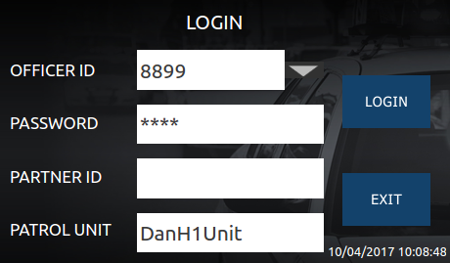

Figure 2: LOGIN Screen

Tap within the designated boxes to input credentials with the virtual keypad, then tap **LOGIN**.

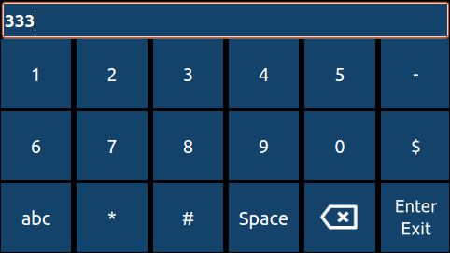

Figure 3: Virtual Keypad

The **Home** screen is displayed.

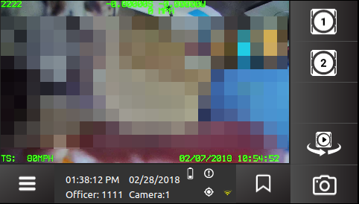

Figure 4: Home Screen

**NOTE**: If you do not have the proper credentials to log in, or choose not to, tap **Exit** to shut the system down.

## Recording a Video

### Record Indicators

A red LED light is situated on the front of the H1 system to signify if the system is recording. It is positioned to be seen through the front windshield when the user is outside the vehicle. The indicator can be enabled or disabled by the Administrator.

### Start/Stop a Recording

*To start a recording, follow these steps:*

1. On the **Home** screen, tap the **Camera** icon you want to start recording with.



1. To sop a recording, tap the **Camera** icon again.

## Create a Bookmark

Bookmarks are used to mark points in a video that the reviewer or user feels are significant. Bookmarks also allow users to quickly locate these significant points of videos during a review.

*To create a bookmark, follow these steps:*

On the **Home** screen, tap the Bookmark icon .

In the Details Display of the **Home** screen, a “Bookmark Created” message is displayed.



Figure 5: Create a bookmark

## Menu Functions

*To access the menu functions, follow these steps:*

On the **Home** screen, tap the **Menu** icon at the lower left of the screen.



Figure 6: Access menu functions

The **FREQUENTLY USED** screen is displayed.

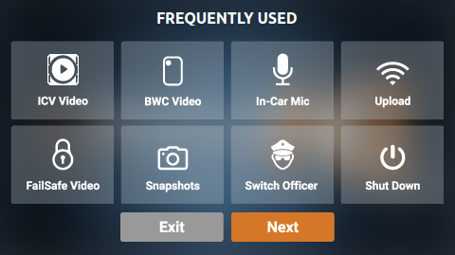

Figure 7: FREQUENTLY USED screen

### Playback ICV Video

*To play In-Car videos, follow these steps:*

1. On the **FREQUENTLY USED** screen, tap the **ICV Video** icon.

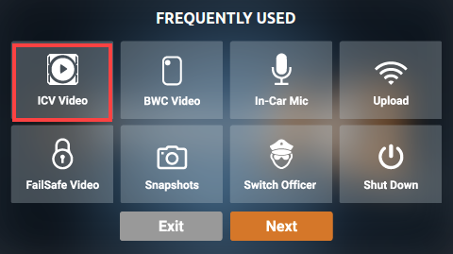

Figure 8: Playback ICV videos

The **ICV VIDEO** screen is displayed with a list of videos.

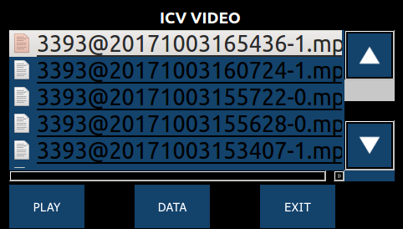

Figure 9: List of ICV videos

1. Tap the video you want to play, then click **PLAY**. The **ICV video playback** screen is displayed.

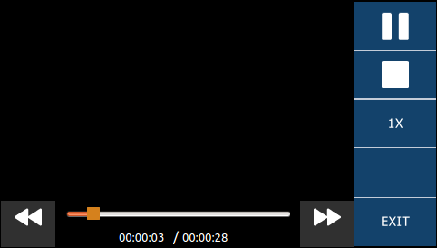

Figure 10: ICV video playback screen

You can tap the pause icon to pause the video. Additionally, you can tap the stop icon to stop the video. If you want to zoom in on the video, tap the **1X** icon.

1. Click **EXIT** to return to the **ICV VIDEO** screen.

#### Add/Edit Metadata for a ICV Video

*To add or edit metadata for a ICV video, follow these steps:*

1. On the **ICV VIDEO** screen, tap the video you want to add/edit metadata to, then click **DATA**. The **DATA** screen is displayed.

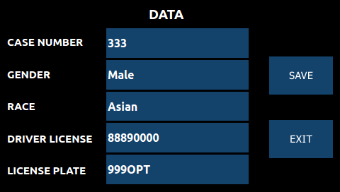

Figure 11: Add/edit metadata for a ICV video

1. Tap on the available fields and enter/select the appropriate data.
2. Tap **Save**.

### Playback BWC Video

*To play Body Worn Camera videos, follow these steps:*

1. On the **FREQUENTLY USED** screen, tap the **BWC Video** icon.

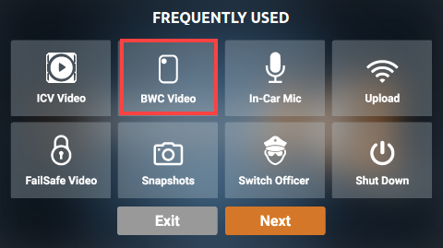

Figure 12: Playback a BWC video

1. On the **BWC Video** screen, tap the video you want to play, then click **PLAY**. The BWC video playback screen is displayed.

You can tap the pause icon to pause the video. Additionally, you can tap the stop icon to stop the video. If you want to zoom in on the video, tap the **1X** icon.

1. Click **Exit** to return to the **BWC VIDEO** screen.

#### Add/Edit Metadata for a BWC Video

*To add or edit metadata for a BWC video, follow these steps:*

1. On the **BWC VIDEO** screen, tap the video you want to add/edit metadata to, then click **DATA**. The **DATA** screen is displayed.
2. Tap on the available fields and enter/select the appropriate data.
3. Click **Save**.

### Turn On/Off In-Car Microphones

*To turn on/off the In-Car microphones, follow these steps:*

1. On the **FREQUENTLY USED** screen, tap the **In-Car Mic** icon to turn on/off.

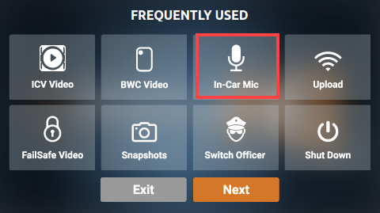

Figure 13: Turn on/off in-car microphones

1. Tap the icon again to turn on/off.
2. To exitthe screen, tap the **Exit** icon.

### Upload Video via Wireless

*To upload videos via wireless network, follow these steps:*

1. On the **FREQUENTLY USED** screen, tap the **Upload** icon.

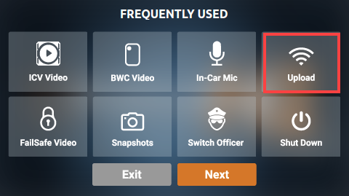

Figure 14: Upload videos via wireless

The **UPLOAD** screen is displayed.

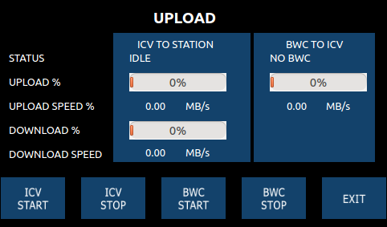

Figure 15: Upload screen

* **Status** – Status of the upload process
* **Upload** **%** – Percentage of upload completed
* **Upload** **Speed** % – Speed of current upload
* **Download** **%** – Percentage of download completed
* **Download** **Speed** – Speed of current download
* **ICV Start** – Tap to start the In-Car video upload
* **ICV Stop** – Tap to stop the In-Car video from uploading
* **BWC Start** – Tap to start the body warn camera upload
* **BWC Stop** – Tap to stop the body warn camera from uploading

1. Click **Exit** to return to the **Frequently Used** screen.

### View FailSafe Videos

*To view failsafe videos, follow these steps:*

1. On the **FREQUENTLY USED** screen, tap the **FailSafe Video** icon.

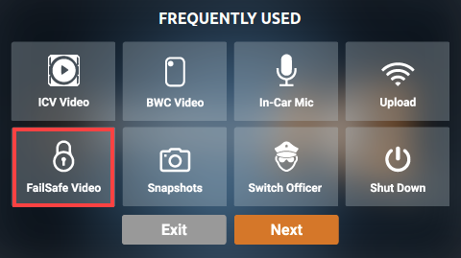

Figure 16: View FailSafe video

The **FAILSAFE VIDEO** screen is displayed.

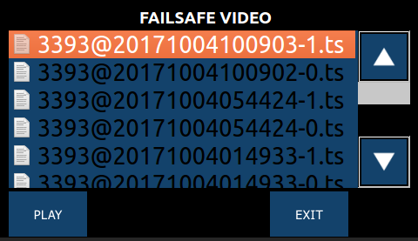

Figure 17: FAILSAFE VIDEO screen

1. Tap the video you want to play, then click **PLAY**. The FailSafe video playback screen is displayed.



Figure 18: Playback a FailSafe video

You can tap the pause icon to pause the video. Additionally, you can tap the stop icon to stop the video. If you want to zoom in on the video, tap the **1X** icon.

1. Click **Exit** to return to the **FAILSAFE VIDEO** screen.

### Take/View a Snapshot

Using the snapshot feature will take a JPG freeze frame image of the video during recording of the current live view camera.

*To take a snapshot, follow these steps:*

On the **Home** screen, tap the Snapshot icon .

In the Details Display of the **Home** screen, a “Snapshot captured.” message is displayed.



Figure 19: Take a snapshot

*To view a snapshot, follow these steps:*

1. On the **FREQUENTLY USED** screen, tap the **SnapShot** icon.

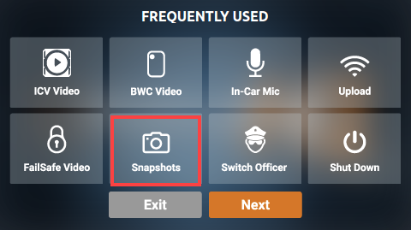

Figure 20: View a snapshot

The **Snapshot List** screen is displayed.

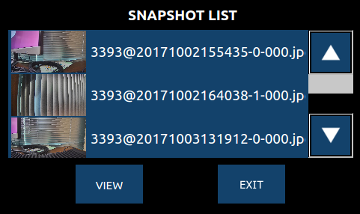

Figure 21: SNAPSHOT LIST screen

1. Tap the snapshot you want to view, then tap **VIEW**. The .jpg of the selected snapshot is displayed.



Figure 22: Snapshot view

1. Tap **EXIT** to return to the **SNAPSHOT LIST** screen.

### Switch Officers

Each video captured on the H1 system is linked to the user ID that is logged into the system at the time the video is captured. The system may be designated, through an internal command, to a different user.

*To switch an officer, follow these steps:*

1. On the **FREQUENTLY USED** screen, tap the **Switch Officer** icon.

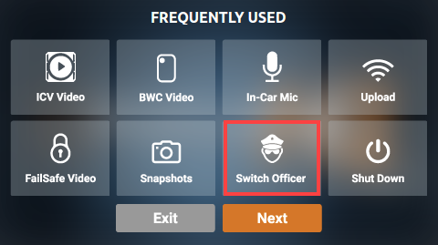

Figure 23: Switch officers

The **LOGIN** screen is displayed.



Figure 24: LOGIN screen

1. Tap the designated boxes to input credentials with the virtual keypad, then tap **LOGIN**.
2. To exit without switching users, tap **Exit**.

### Shut Down the System

*To shut down the H1 system, follow these steps:*

1. On the **FREQUENTLY USED** screen, tap the **Shut Down** icon.

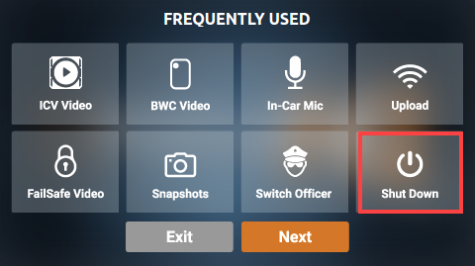

Figure 25: Shut down the system

A confirmation screen is displayed.

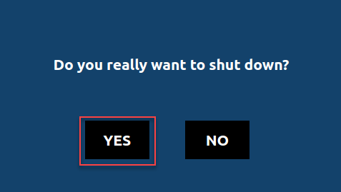

Figure 26: Confirmation of shutdown

1. Tap **Yes**.

## Working with System Settings

### Access the System Settings

*To access the system settings, follow these steps:*

1. On the **FREQUENTLY USED** screen, tap **Next**.

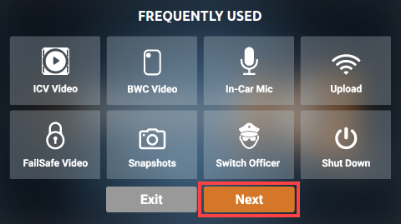

Figure 27: Access the system settings

The **SYSTEM SETTING** screen is displayed.

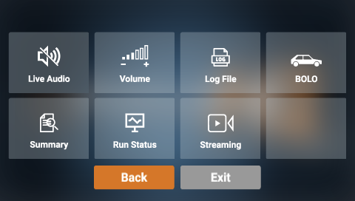

Figure 28: SYSTEM SETTING screen

1. To exitthe screen, tap the **Exit** icon.

### Turn On/Off Live Audio

The Live Audio feature allows audio from the body-worn wireless microphone transmitted through the in-car system.

*To turn the live audio on or off, follow these steps:*

1. On the **SYSTEM SETTING** screen, tap the **Live Audio** icon to turn on/off.

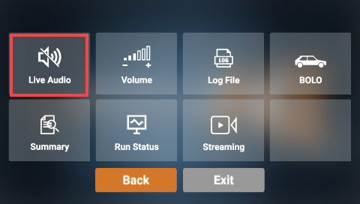

Figure 29: Turn on/off live audio

1. Tap the icon again to turn on/off.
2. To exitthe screen, tap the **Exit** icon.

### Adjust the Volume

The Volume Control allows you to adjust the system’s volume and left/right sound channels.

*To adjust the volume, follow these steps:*

1. On the **SYSTEM SETTING** screen, tap the **Volume** icon.

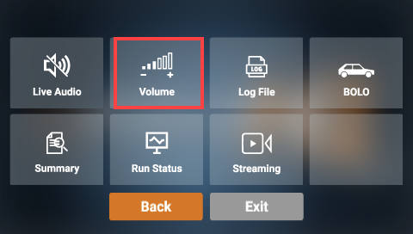

Figure 30: Adjust the volume

The **VOLUME CONTROL** screen is displayed.

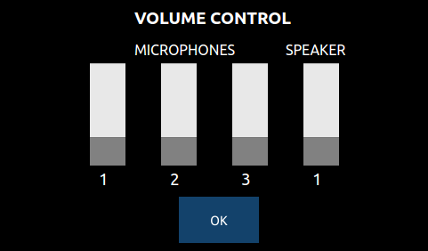

Figure 31: VOLUME CONTROL screen

1. Touch the grey areas to move the levels up or down, then tap **OK** to accept the changes, or **Cancel** to exit without saving. Either command will exit the **VOLUME CONTROL** screen.

### View Log File

*To view a log file, follow these steps:*

1. On the **SYSTEM SETTING** screen, tap the **Log File** icon.

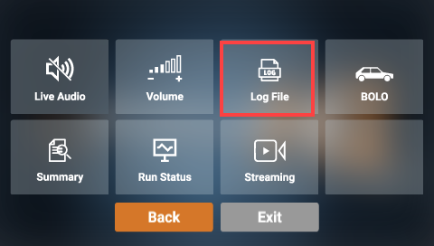

Figure 32: View log files

The **LOG FILES** screen is displayed.

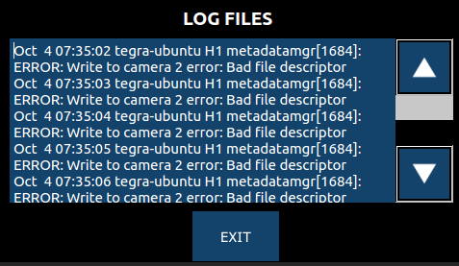

Figure 33: LOG FILES screen

1. To exitthe screen, tap the **Exit** icon.

### Viewing the System Summary

The system summary provides users with details about the system’s recording capacity, as well as GPS status and coordinates, and system date and time.

*To view a system summary, follow these steps:*

1. On the **SYSTEM SETTING** screen, tap the **Summary** icon.

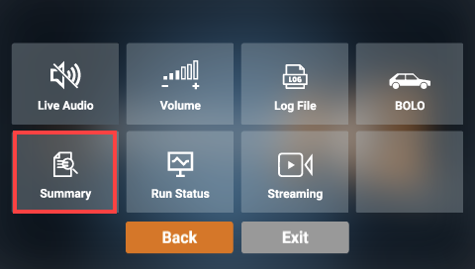

Figure 34: View the system summary

The **System Version** screen is displayed.

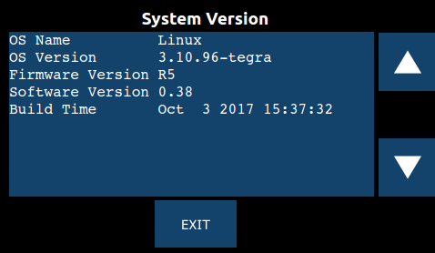

Figure 35: System Version screen

1. Tap the down arrow to view the **FailSafe & PenDrive** summary screen.

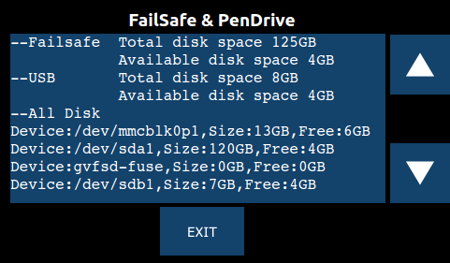

Figure 36: Failsafe & PenDrive summary screen

1. Tap the down arrow again to view the **Current Status** screen.

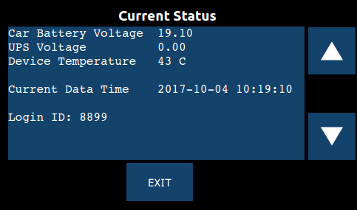

Figure 37: Current Status screen

1. Tap the down arrow again to view the **GPS Info** screen.

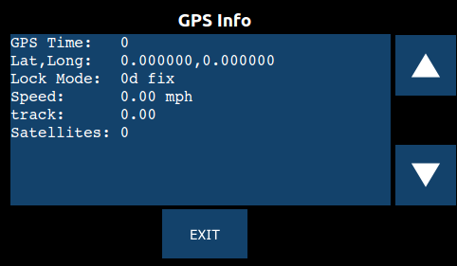

Figure 38: GPS Info screen

1. To exitthe screen, tap the **Exit** icon.

### Run a Diagnostic Status Report

*To run a diagnostic status report, follow these steps:*

1. On the **SYSTEM SETTING** screen, tap the **Run Status** icon.

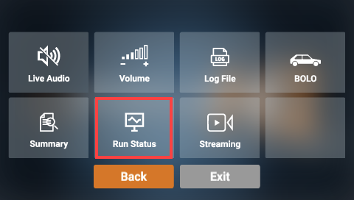

Figure 39: Run a status report

The **RUN STATUS** screen is displayed.

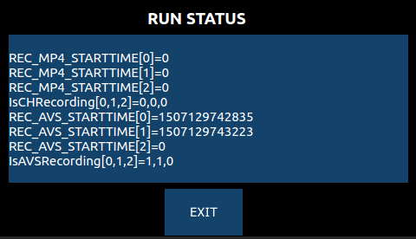

Figure 40: RUN STATUS screen

1. To exitthe screen, tap the **Exit** icon.

### Access Live Streaming Videos

*To access streaming videos, follow these steps:*

1. On the **SYSTEM SETTING** screen, tap the **Streaming** icon.

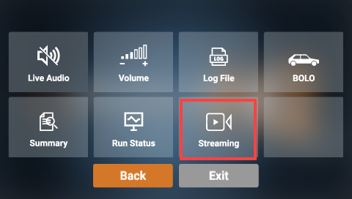

Figure 41: Access live streaming videos

1. To exitthe screen, tap the **Exit** icon.

# Obtain COBAN Support

COBAN offers the following ways to obtain support. Before you contact us, please have the following information ready to provide Support:

* Department Name
* Name of the registered contact with COBAN. If not registered within our system as an authorized contact, contact your project manager and request to be added to our contact list. Failure to do so may delay support assistance.
* Best contact number and preferred contact time
* Error Code/Description of issue you are experiencing
* Troubleshooting steps already taken

*To obtain COBAN support:*

**Call** support at 281-925-0488, then select Option 2. You can hold for immediate assistance or leave a voicemail for COBAN Support to respond as soon as possible.

*Mon-Fri 8:00am to 6:00pm Central Standard Time (CST)*

**Email** Support at hwsupport@cobantech.com and include a detailed description of the issue you are experiencing. Also include any troubleshooting steps you have taken to resolve the issue. Support may request additional information or troubleshooting.

**Submit a Ticket** via our Website at<https://www.cobantech.com/support> and provide a good description of the issue you are experiencing and what troubleshooting steps have been taken in the comments section before submitting the form. Support may request additional information or troubleshooting.

**Search our knowledge base** at <http://kb.cobantech.com/> for resolutions to known issues, documents, manuals and more. Login is required for access to COBAN's knowledge base. If you do not have login credentials, please request one from support at hwsupport@cobantech.com. Ensure you are a registered COBAN contact before requesting access.