

*COBAN FOCUS H1 In-Car Video System   
Installation Guide*

*v. 1.0.2*

COBAN® Technologies Inc.

11375 West Sam Houston Parkway South, Suite 800

Houston, Texas 77031

Tel: 1-281-925-0488

Fax: 1-281-925-0535

<http://www.cobantech.com>

Copyright

THE SPECIFICATIONS AND INFORMATION REGARDING THE PRODUCTS IN THIS MANUAL ARE SUBJECT TO CHANGE WITHOUT NOTICE. ALL STATEMENTS, INFORMATION, AND RECOMMENDATIONS IN THIS MANUAL ARE BELIEVED TO BE ACCURATE BUT ARE PRESENTED WITHOUT WARRANTY OF ANY KIND, EXPRESS OR IMPLIED. USERS MUST TAKE FULL RESPONSIBILITY FOR THEIR APPLICATION OF ANY PRODUCTS.

THE SOFTWARE LICENSE AND LIMITED WARRANTY FOR THE ACCOMPANYING PRODUCT ARE SET FORTH IN THE INFORMATION PACKET THAT SHIPPED WITH THE PRODUCT AND ARE INCORPORATED HEREIN BY THIS REFERENCE. IF YOU ARE UNABLE TO LOCATE THE SOFTWARE LICENSE OR LIMITED WARRANTY, CONTACT YOUR COBAN TECHNOLOGIES REPRESENTATIVE FOR A COPY.

NOTWITHSTANDING ANY OTHER WARRANTY HEREIN, ALL DOCUMENT FILES AND SOFTWARE OF THESE SUPPLIERS ARE PROVIDED “AS IS” WITH ALL FAULTS. COBAN TECHNOLOGIES AND NAMED SUPPLIERS DISCLAIM ALL WARRANTIES, EXPRESSED OR IMPLIED, INCLUDING, WITHOUT LIMITATION, THOSE OF MERCHANTABILITY, FITNESS FOR A PURPOSE AND NON-INFRINGEMENT OR ARISING FROM A COURSE OF DEALING, USAGE, OR TRADE PRACTICE.

IN NO EVENT SHALL COBAN TECHNOLOGIES OR ITS SUPPLIERS BE LIABLE FOR ANY INDIRECT, SPECIAL, CONSEQUENTIAL, OR INCIDENTAL DAMAGES, INCLUDING, WITHOUT LIMITATION, LOST PROFITS OR LOSS OR DAMAGE TO DATA ARISING OUT OF THE USE OR INABILITY TO USE THIS MANUAL, EVEN IF COBAN TECHNOLOGIES OR ITS SUPPLIERS HAVE BEEN ADVISED OF THE POSSIBILITY OF SUCH DAMAGES.

COBAN AND THE COBAN LOGO ARE TRADEMARKS OF COBAN TECHNOLOGIES. THIRD-PARTY TRADEMARKS MENTIONED ARE THE PROPERTY OF THEIR RESPECTIVE OWNERS. THE USE OF THE WORD “PARTNER” DOES NOT IMPLY A PARTNERSHIP RELATIONSHIP BETWEEN COBAN TECHNOLOGIES AND ANY OTHER COMPANY.

ANY INTERNET PROTOCOL (IP) ADDRESSES AND PHONE NUMBERS USED IN THIS DOCUMENT ARE NOT INTENDED TO BE ACTUAL ADDRESSES AND PHONE NUMBERS. ANY EXAMPLES AND FIGURES INCLUDED IN THE DOCUMENT ARE SHOWN FOR ILLUSTRATIVE PURPOSES ONLY. ANY USE OF ACTUAL IP ADDRESSES OR PHONE NUMBERS IN ILLUSTRATIVE CONTENT IS UNINTENTIONAL AND COINCIDENTAL.

*COBAN FOCUS H1 In-car Video System Installation Guide v1.0.2*

2018 COBAN™ TECHNOLOGIES. ALL RIGHTS RESERVED.

Revisions

|  |  |  |
| --- | --- | --- |
| 3/22/2018 | Addition of Wireless Microphone Information | *v1.0.1* |
| 7/13/2018 | Additional Edits | *v1.0.2* |

Table of Contents

[Revisions 2](#_Toc519239456)

[1 Introduction 4](#_Toc519239457)

[1.1 Purpose 4](#_Toc519239458)

[2 Install the FOCUS H1 5](#_Toc519239459)

[2.1 Package Contents 5](#_Toc519239460)

[2.2 Mounting List 5](#_Toc519239461)

[2.3 Mount the CPU 5](#_Toc519239462)

[2.4 Mount the Monitor 6](#_Toc519239463)

[2.5 Mount the Front Camera 7](#_Toc519239464)

[2.6 Mount the Backseat Camera 7](#_Toc519239465)

[2.7 Wire the FOCUS H1 8](#_Toc519239466)

[2.7.1 Power Harness 8](#_Toc519239467)

[2.7.2 Monitor 8](#_Toc519239468)

[2.7.3 Front Camera 9](#_Toc519239469)

[2.7.4 Backseat Camera 9](#_Toc519239470)

[2.7.5 I/O Cable 10](#_Toc519239471)

[2.8 Peripherals 10](#_Toc519239472)

[2.8.1 GPS 10](#_Toc519239473)

[2.9 Wireless Microphone 11](#_Toc519239474)

[2.9.1 Sync the Wireless Microphone 11](#_Toc519239475)

[3 Install the H1 MDC Application 12](#_Toc519239476)

[4 Obtain COBAN Support 15](#_Toc519239477)

# Introduction

This document is intended for use with COBAN H1 (H1) In-Car Video System and contains instructions for using the COBAN FOCUS H1.

COBAN manufactures state-of-the-art mobile data computers and digital video recording equipment for use in the public safety, utility and military community. In addition to innovative mobile computing devices and digital video technology, COBAN employs the latest communication, database, and storage technologies to deliver complete and scalable solutions to our customers, regardless of the size of the agency.

**DISCLAIMER**: Due to variations in vehicles, agency equipment requirements, and the placement of existing equipment, every installation in a public safety vehicle is unique. This manual assumes and illustrates installations in Ford Crown Victoria, Chevy Impala, Silverado and Tahoe, as well as Dodge Charger and Magnum.

The information contained herein is subject to change without notice. COBAN Technologies reserves the right to make changes to this product, has no obligation to update or keep current the information contained within, and assumes no responsibility for any errors or omissions that may be present in this document.

## Purpose

The H1 is a high definition (1080p) in-car video recorder intended for the law enforcement market. Additionally, the H1 is designed to allow for Edge computing. The design recognizes the significant benefit that can be gained by law enforcement with real-time analytics that don’t rely on a high bandwidth connection back to the cloud. This document describes the overall hardware design/capabilities and the intended and desired structure and function of the software/firmware.

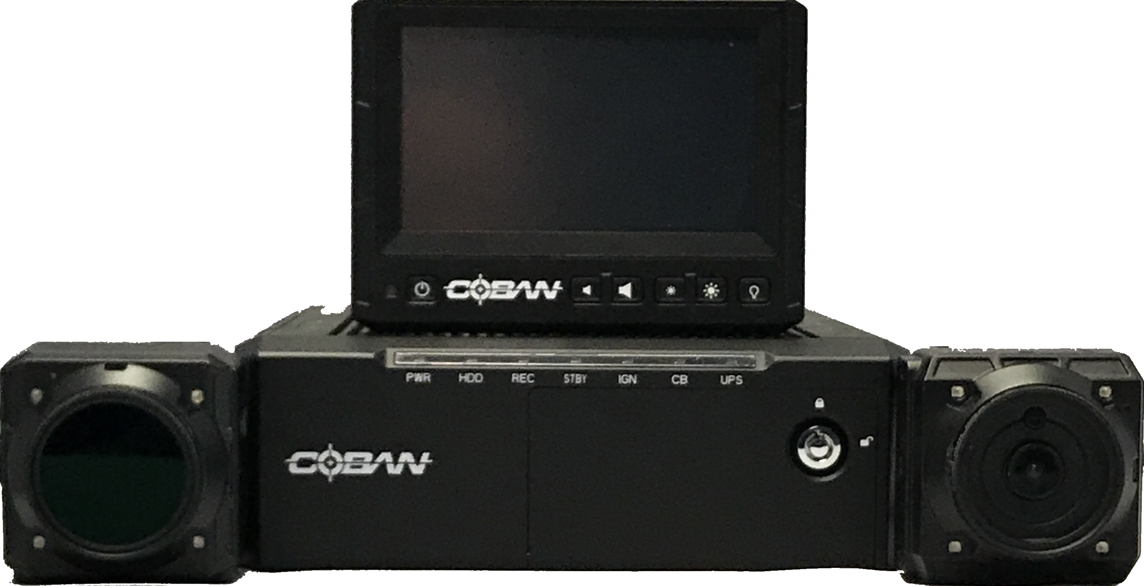

# Install the FOCUS H1

## Package Contents

|  |  |  |  |
| --- | --- | --- | --- |
|  |  |  |  |
| **FOCUS H1 CPU** | **Front Camera** | **Backseat Camera** | **H1 Monitor** |

|  |  |  |  |  |  |
| --- | --- | --- | --- | --- | --- |
|  | cid:ii_jflav35k3_162917694b741422 | |  | cid:ii_jflav34w1_162917694b741422 | |
| **GPS** | **Power Harness** | | **Monitor/Camera Extension Cable** | **I/O Cable** | |
|  | |  | | |
| **Drive Key Removable Drive** | | | | |

## Mounting List

|  |  |  |  |
| --- | --- | --- | --- |
|  |  |  |  |
| **CPU Mount** | **Front Camera Mirror Mount** | **Backseat Camera Mount** | **Monitor Mount** |

## Mount the CPU

|  |  |  |
| --- | --- | --- |
|  |  | |
| **Front** | | **Back** |

*To mount the CPU, follow these steps:*

1. Locate a flat surface.
2. Use the 4 self-tapping screws to secure the mounting bracket.

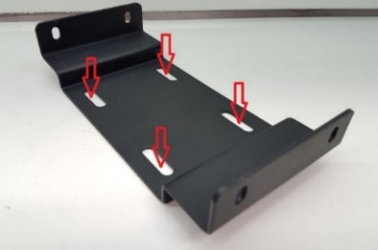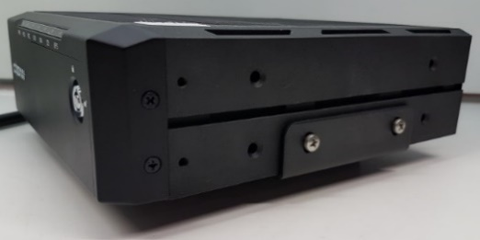

**NOTE**: Be careful not to damage the vehicle’s fuel tank with the self-tapping screws.

## Mount the Monitor

**NOTE**: Additional mounting locations will be available at a later date.

*To mount the FOCUS H1 monitor, follow these steps:*

1. Attach the Ram Diamond Ball Mount and secure it to the back of the monitor with the   
   8-32 machine screws.

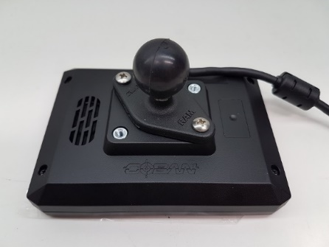

1. Mount the second Ram Diamond Ball Mount to the vehicle using the self-tapping screws and attach the monitor assembly to the vehicle using the Ram arm as shown in the example below.

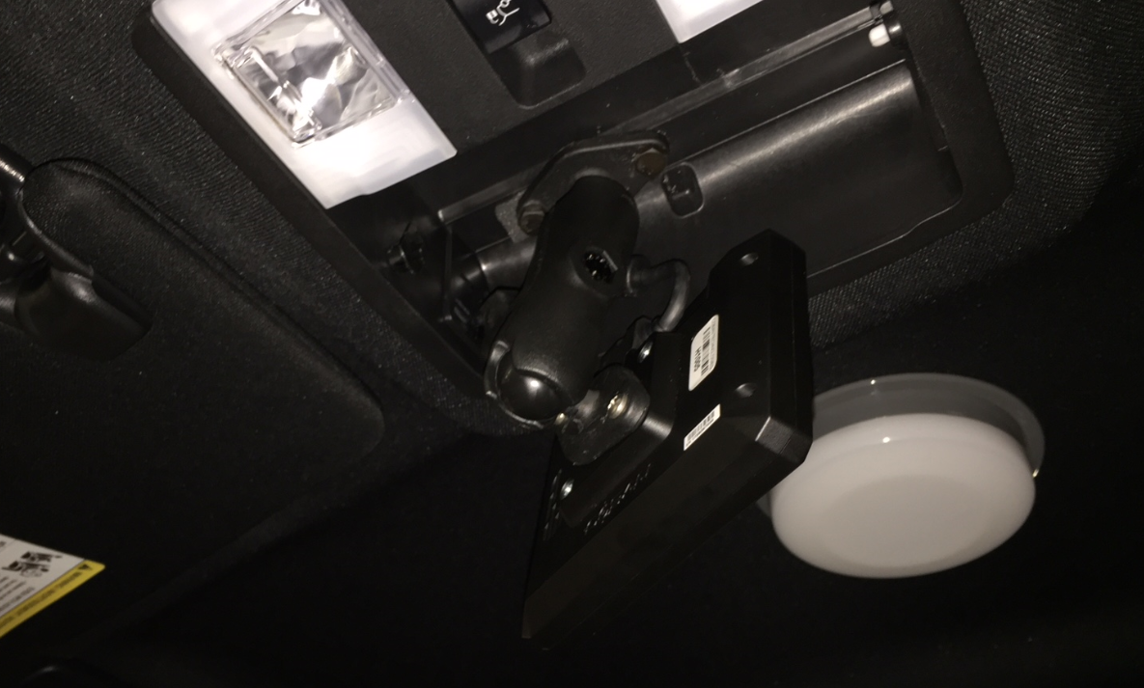

1. Adjust the monitor to the desired position and tighten the ram mount as shown in the example below.

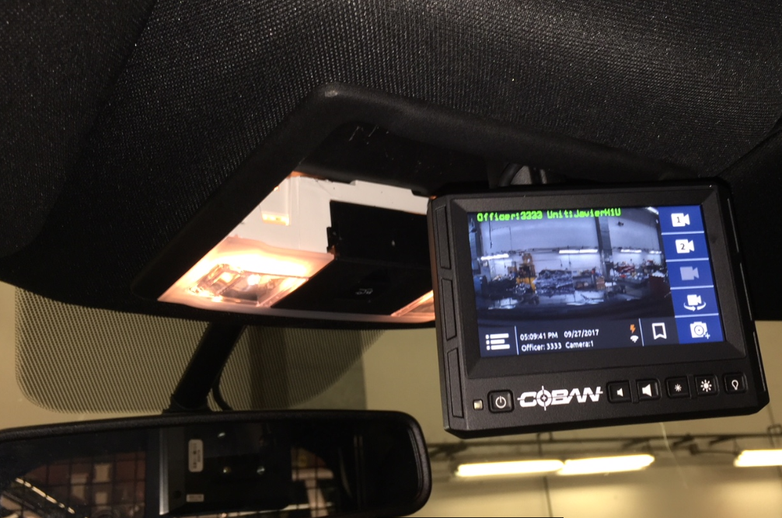

## Mount the Front Camera

If not using the Mirror Mount Clamp the COBAN H1 system requires an adapter/anchor plate, be installed on the vehicle to secure the overhead camera mount in all vehicles except for the Ford Crown Victoria.

*To mount the front camera on the mirror post, follow these steps:*

1. Assemble the adjustable Panavise mount to the mirror mount clamp.

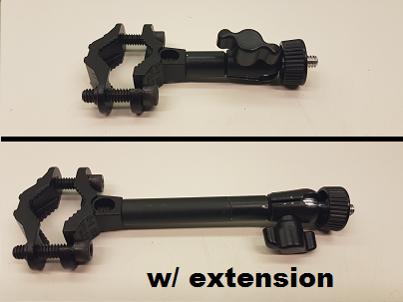

**NOTE**: To reduce possible vibration, only use the included extension if the camera needs to be farther away from the mirror post.

1. Place the clamp mount around the mirror post loosely until the best position has been found that allows the camera to be aimed and levelled properly.

|  |  |
| --- | --- |
|  |  |

1. Once positioned, tighten the bolts using the provided hex L-key.
2. Verify all cables are clear before tightening the clamp mount.
3. Attach the front camera to the mount and make necessary adjustments to properly aim the camera.
4. Tighten the ¼-20 “Knob” nut to secure it in place.

**NOTE**: In some cases, the adjustable “Knob” nut may need to be removed. In the case where the agency does not want the camera to be adjustable, an Allen screw can be used to replace the wing nut if needed.

## Mount the Backseat Camera

*To mount the backseat camera, follow these steps:*

1. Position the wall mount plate in the desired area and secure with the (2) provided   
   self-drilling/taping screws.
2. Attach the camera mount bracket to the back of the camera with the (1) provided black ¼-20 flange bolt
3. Attach the camera mount bracket to the wall mount plate with the (4) provided 8-32 screws, make necessary adjustments to properly aim the camera.
4. Route the cable behind the camera so it is not visible.

**NOTE**: Tighten the screws securely and verify that the camera does not move when finished.

Wall Mount Plate Camera Mount Bracket Step -1 Step -2  Step -3 Step -4

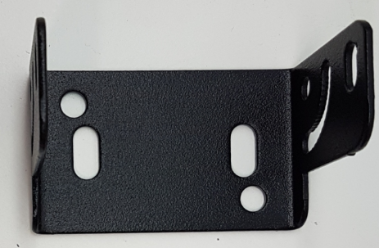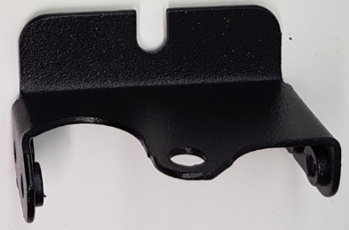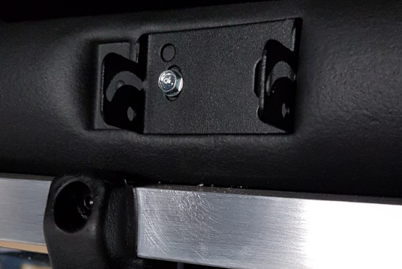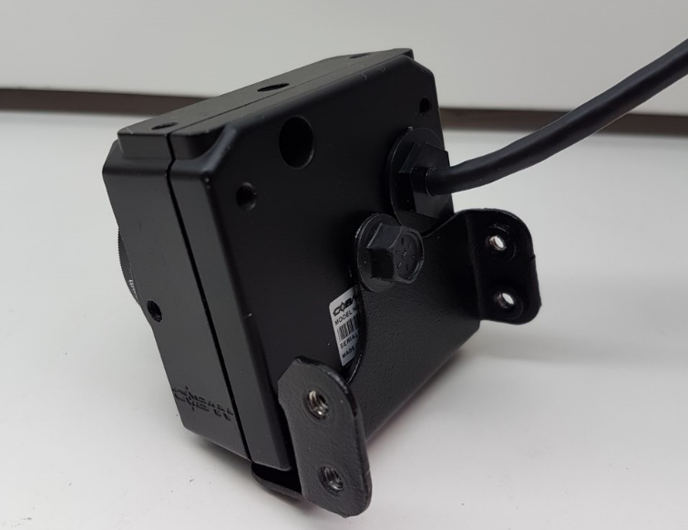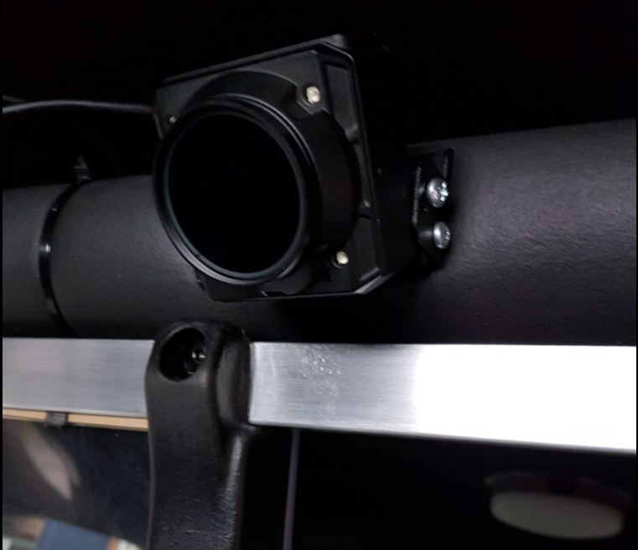 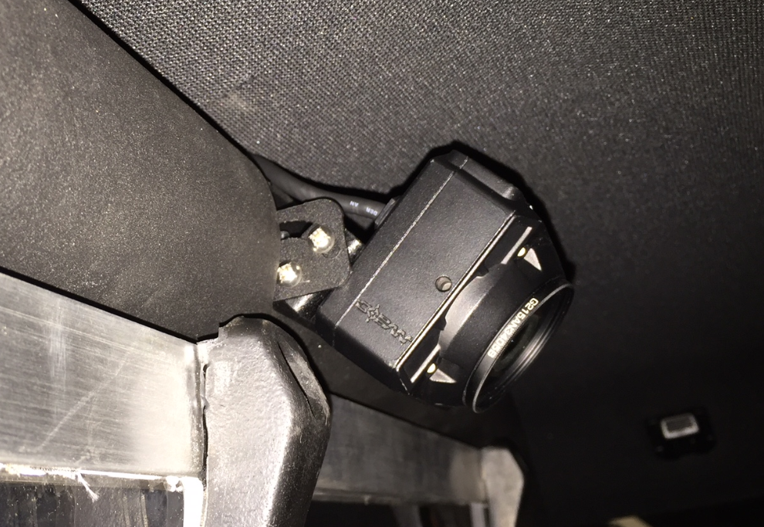

## Wire the FOCUS H1

### Power Harness

*To wire the FOCUS H1 using the Power Harness, follow these steps:*

1. Using the Power Harness, run the RED and BLACK wires from the CPU to the vehicle’s battery.

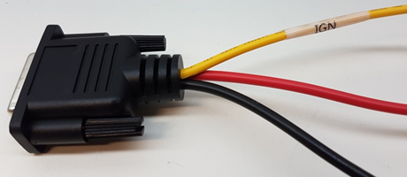

1. Attach the BLACK wire to ground.
2. Take the inline fuse holder and remove the fuse.

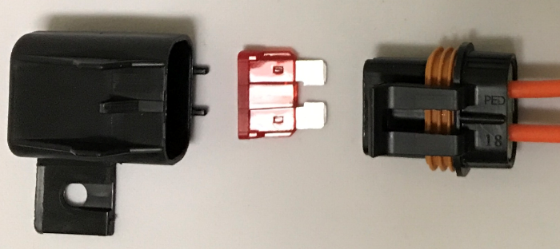

1. Securely attach the fuse holder in-line to the RED wire and then attach to the positive side on the battery.
2. Run the ORANGE wire to the dash and connect it to an ignition source.

**NOTE**: Some early versions of the power harness included a YELLOW wire for Ignition.

1. Connect the Power Harness to the power pigtail on the CPU.
2. Reattach the fuse back into the fuse holder.



### Monitor

*To wire the monitor, follow these steps:*

1. Run the monitor extension cable marked **#0** from the monitor location to the CPU.

**NOTE**: The cable # is on the bottom side of the connector.

1. Connect the monitor pigtail to the monitor extension cable.
2. Connect the monitor extension to the port on the back of the CPU labelled **LCD.**

**NOTE**: For proper orientation make sure the top flat side of the connector is facing up.

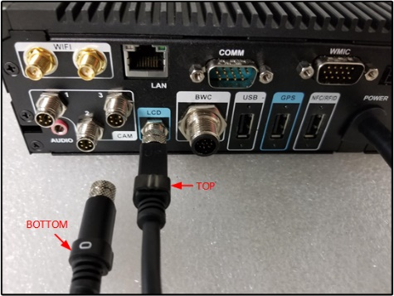

### Front Camera

*To wire the front camera, follow these steps:*

1. Run the camera extension cable marked **#1** from the front camera location to the CPU.

**NOTE**: The cable # is on the bottom side of the connector.

1. Connect the camera pigtail to the camera extension cable.
2. Connect the camera extension to the port on the back of the CPU labelled **CAM 1**.

**NOTE**: For proper orientation make sure the top flat side of the connector is facing up.

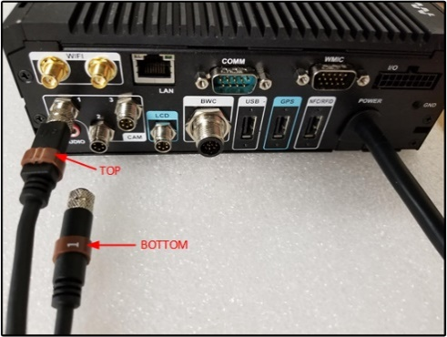

### Backseat Camera

*To wire the backseat camera, follow these steps:*

1. Run the camera extension cable marked **#2** from the backseat camera location to the CPU.

**NOTE**: The cable # is on the bottom side of the connector.

1. Connect the camera pigtail to the camera extension cable.
2. Connect the camera extension to the port on the back of the CPU labelled **CAM 2**.

**NOTE**: For proper orientation make sure the top flat side of the connector is facing up.

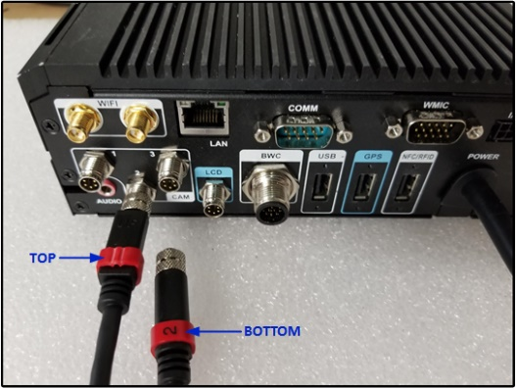

### I/O Cable

*To connect the I/O cable, follow these steps:*

1. Connect the I/O cable to the port on the CPU labelled **I/O**.
2. Attach the Black wire with the Yellow Stripe to a 12V output signal from the lightbar.

**NOTE**: Digital Inputs and outputs are configured in the Command Center Back office.

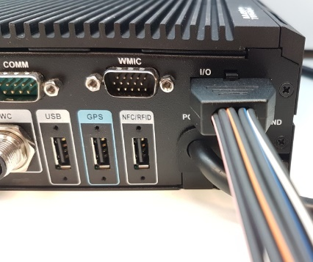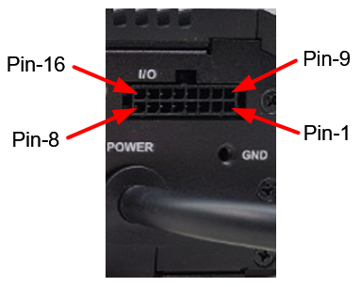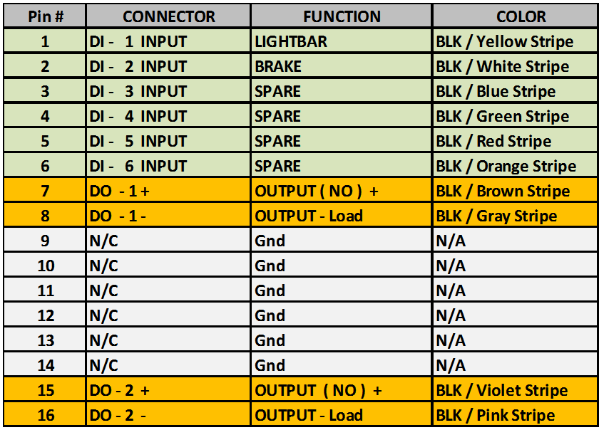

## Peripherals

### GPS

*To wire the GPS, follow these steps:*

1. Place the GPS receiver near a window to allow better connection with satellite.
2. Run the cable to the CPU and plug it into the port labelled **GPS**.
3. Tighten the connector screws.

## Wireless Microphone

|  |
| --- |
| C:\Users\JuliaD\AppData\Local\Temp\SNAGHTML1e7685.PNG |

The H1 In-car video system supports up to two wireless microphones, in addition to the In-car microphone. To access the secondary receiver contacts, remove the cover located near the primary receiver.

When a recording on camera 1 is started, the wireless microphones are turned on. When camera 1 is stopped, the microphones are turned off.

The microphone has the following three buttons:

* **Rec** – larger button on top
* **PB1** – smaller button on top. This is a programmable function button.
* **PB2** – side button. This is a programmable function button.

If there are two wireless microphones, their push buttons are given the same functions.

* **Mute** – mutes the sound from the wmic. When mute is on, a button LED displays. When the mute is off the button LED is turned off.
* **Marker** – records the time when the button is pressed. This is the same as a bookmark.
* **TriggerCam2** – starts camera2.
* **Snapshot** –This is the same as the snapshot function on the live view screen.

### Sync the Wireless Microphone

*To sync the wireless microphone, follow these steps:*

1. Verify your microphones are fully charged.
2. Power on the In-car Video System.
3. Touch the microphone contacts (located on the bottom of the wireless microphone unit) to the receiver’s register contacts.

A confirmation tone sounds indicating the receiver and microphone have synchronized frequencies. The microphone is now in *Standby* mode and ready for use.

1. If necessary, repeat these steps with additional microphones while ensuring each is synched to its own receiver.

**NOTE**: Syncing a second microphone to the same receiver will replace and nullify the first microphone.

# Install the H1 MDC Application

*To install the H1 MDC application, follow these steps:*

1. Right-click **H1 MDC Application.exe** and select **Run as Administrator** from the context menu. The **Open File – Security Warnin**g dialog box is displayed.

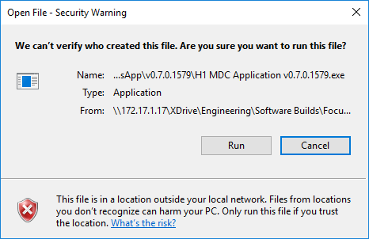

1. Click **Run**. The **Select Destination Location** panel is displayed.

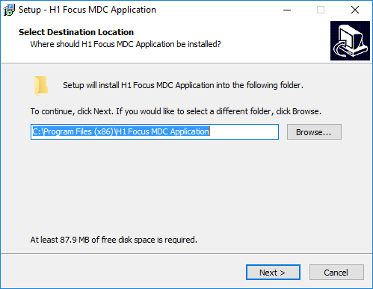

1. Accept the default path, and then click **Next**. The Select Additional Tasks panel is displayed.



1. Select the additional tasks you want Setup to perform while installing the H1 Focus MDC Application, then click **Next**. The Ready to Install panel is displayed.

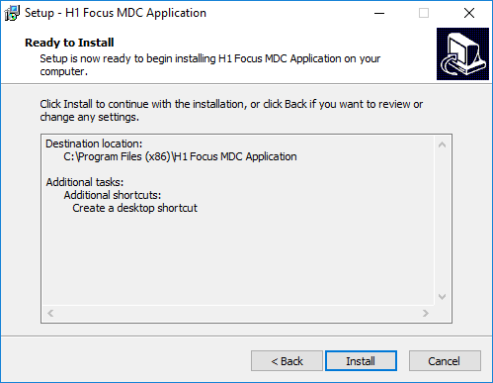

1. Click **Install** to begin the installation. Once installation is complete, the Completing panel is displayed.

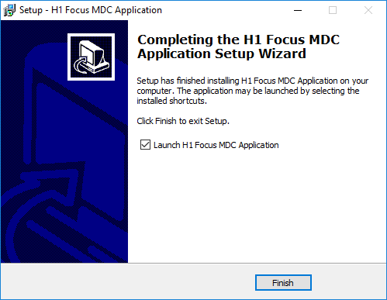

1. Click **Finish**.

# Obtain COBAN Support

COBAN offers the following ways to obtain support. Before you contact us, please have the following information ready to provide Support:

* Department Name
* Name of the registered contact with COBAN. If not registered within our system as an authorized contact, contact your project manager and request to be added to our contact list. Failure to do so may delay support assistance.
* Best contact number and preferred contact time
* Error Code/Description of issue you are experiencing
* Troubleshooting steps already taken

*To obtain COBAN support:*

**Call** support at 281-925-0488, then select **Option 2**. You can hold for immediate assistance or leave a voicemail for COBAN Support to respond as soon as possible.

*Mon-Fri 8:00am to 6:00pm Central Standard Time (CST)*

**Email** Support at [hwsupport@cobantech.com](file:///Z:\Product%20Management\Working\COBAN%20Redact\hwsupport@cobantech.com) and include a detailed description of the issue you are experiencing. Also include any troubleshooting steps you have taken to resolve the issue. Support may request additional information or troubleshooting.

**Submit a Ticket** via our Website at<https://www.cobantech.com/support> and provide a good description of the issue you are experiencing and what troubleshooting steps have been taken in the comments section before submitting the form. Support may request additional information or troubleshooting.

**Search our knowledge base** at <http://kb.cobantech.com/> for resolutions to known issues, documents, manuals and more. Login is required for access to COBAN's knowledge base. If you do not have login credentials, please request one from support at [hwsupport@cobantech.com](file:///Z:\Product%20Management\Working\COBAN%20Redact\hwsupport@cobantech.com). Ensure you are a registered COBAN contact before requesting access.