H1 Cheat Sheet
LOGIN  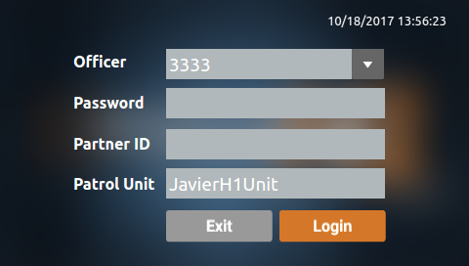  *Power on your H1.  *Press the OFFICER ID, PASSWORD, PARTNER ID or PATROL UNIT fields for Virtual Keypad.  *Press LOGIN to advance to the home screen. |  |  | START/STOP RECORDING  *Additionally, you can start recording using your trigger microphone. To stop recording using your trigger microphone, you can configure this button on the microphone. See your COBAN H1 Adminstrator’s manual. |  |  | * Press camera 1 to start recording with front camera  * Press camera 2 to start recording with rear camera  * Press camera 3 to start recording with extra camera  * Press the camera button again to stop recording.  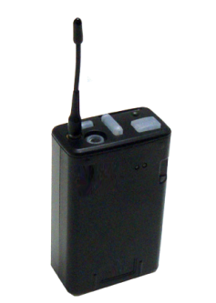
*Once a recording is stopped, you will be prompted to enter data associated with the video. Enter the data, then click Save.
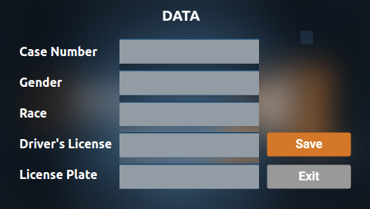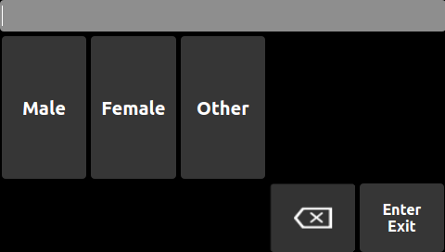
ICV/BWC VIDEO PLAYBACK *On the home screen, press the MENU button to advance to the FREQUENTLY USED screen.
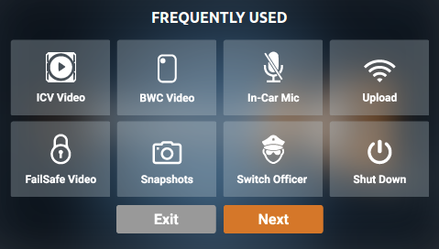 | * Press the ICV VIDEO or BWC Video buttons to play either In-car videos or Body Worn Camera videos.  * Select a video from the list, then press PLAY. |  |  | 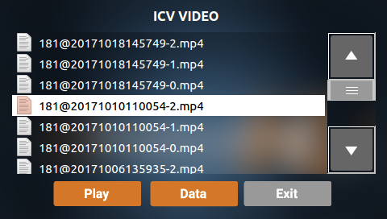
IN-CAR MIC *On the home screen, press the MENU button to advance to the FREQUENTLY USED screen.
 | *Press IN-CAR MIC to toggle the In-car Microphone on/off.
UPLOAD VIDEO *On the home screen, press the MENU button to advance to the FREQUENTLY USED screen.
 |  | *Tap UPLOAD.  *Press the buttons at the bottom to start/stop your ICV or BWC upload. |  |  | 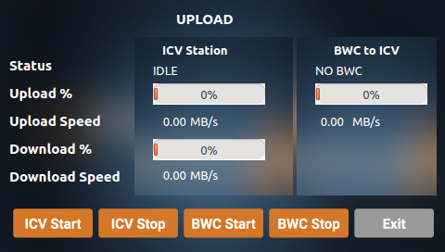

FAILSAFE VIDEO PLAYBACK *On the home screen, tap the MENU button to advance to the FREQUENTLY USED screen.
While the camera is powered on, the system automatically records ALL activity and stores it to a failsafe drive. In the event of loss of data, the system will be able to retrieve damaged/removed data.
 |  |  |  |  | * Press FAILSAFE VIDEO.  * Press a video, then press PLAY. |  |  |  | 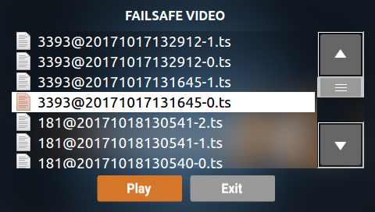  *Review videos, bookmark or play at 2X speed
 | TAKE SNAPSHOT/BOOKMARK *On the home screen, press the MENU button to advance to the Frequently Used screen.
* Press the SNAPSHOT button. A confirmation message is displayed.
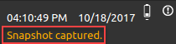

 | SWITCH OFFICER
*Tap SWITCH OFFICER.
*Press in the designated boxes to input credentials with the virtual keypad, then tap LOGIN.
 |  | SHUTDOWN
 |  |  |  |  |  |  | * Press SHUTDOWN, then press YES. |  |  | 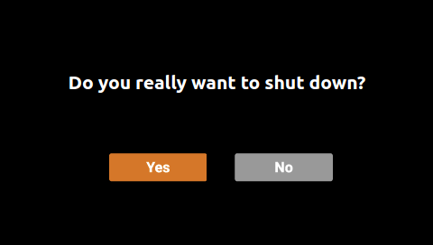
MORE FUNCTIONS
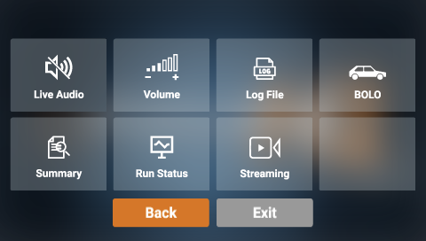 |  |  | LIVE AUDIO: Press this button to playback live audio from microphone through the speakers.  VOLUME: Press this button to adjust speaker volume.  LOG FILE: Press this button to view the system log file.  SUMMARY: Press this button to view details regarding the system’s platform, OS version, Firmware version, Software version, and the Build time for the software version  RUN STATUS: Press this button to view the status of the current session.

